Center: FAT 2

590 Cach Mang Thang Tam street, District 3, HCM city

Design Document

**ALLURING DECORS**

Faculty:

Batch No:

Group No: Group

Members:

|  |  |
| --- | --- |
| Full Name | Roll No. |
|  |  |
|  |  |
|  |  |

Review 1

1. Problem Definition 6

2. General Requirement Specification: 6

3. Function Requirement Specification: 7

3.1 Guest can register as User 7

3.2 Guest can login as User 7

3.3 Guest and user can view domain 7

3.4 Guest and user can view service 8

3.5 Guest and user can view project 8

3.6 Guest can send feedback to admin 8

3.7 User can add service to cart 8

3.8 User can checkout 9

3.9 User can view his/her profile 9

3.10 User can change his/her profile 9

3.11 User can change his/her password 9

3.12 User can view transaction history 10

3.13 User can cancel the order 10

3.14 Admin can manage user 10

3.15 Admin can manage domain 11

3.16 Admin can manage services 11

3.17 Admin can manage Project 11

3.18 Admin can manage feedback 12

3.19 Admin can manage bill 12

3.20 Admin can view system statitics 12

3.21 Admin can change password 12

3.22 Admin can manage business profile 13

3.23 Admin can manage FAQ question 13

4. Non-Function Requirement Specification 13

4.1 Evolution 13

4.2 Friendliness 13

4.3 Safeness 13

5. System Requirement 14

5.1 Hardware 14

5.2 Software 14

6. Development Software 15

7. Techonology 15

8. Task Sheet 16

Review 2

1. Use Case and Sequence Diagram 18

1.1 Guest 18

1.1.1 Guest can register as User 18

1.1.2 Guest can login as User 22

1.1.3 Guest and user can view domain 24

1.1.4 Guest and user can view service 26

1.1.5 Guest and user can view project 27

1.1.6 Guest can send feedback to admin 29

1.2 User 31

1.2.1 User can add service to cart 31

1.2.2 User can checkout 32

1.2.3 User can view his/her profile 35

1.2.4 User can change his/her profile 36

1.2.5 User can change his/her password 38

1.2.6 User can view transaction history 41

1.2.7 User can cancel the order 42

1.3 Admin 43

1.3.1 Admin can manage user 43

1.3.2 Admin can manage domain 45

1.3.3 Admin can manage services 49

1.3.4 Admin can manage Project 54

1.3.5 Admin can manage feedback 58

1.3.6 Admin can manage bill 60

1.3.7 Admin can view system statitics 62

1.3.8 Admin can change password 63

2. Entity Relationship Diagram (ERD) 65

2.1 Conceptual 65

2.2 Entity 66

2.2.1 Admin 66

2.2.2 Feedbacks 66

2.2.3 Domains 66

2.2.4 Services 67

2.2.5 Projects 67

2.2.6 Images 68

2.2.7 Users 68

2.2.8 Bills 69

2.2.9 BillDetails 69

3. Task Sheet 71

**REVIEW 1**

# Problem Definition

Our Client “**Alluring Decors**” is one of the upcoming Interior and Exterior Designers in the territory. They had been in to this profession since 5 years down the line. They deal with the Interior and Exterior Decoration of the houses, offices, shops, malls, etc. based on the contract that they had received from their clients.

Alluring Decors, in general advertise about their work through the news papers, TV advertisements, hoardings, banners, and through the internet (some other advertising websites) for which they should have to incur certain amount for advertising. Also for advertising they cannot go up to a full extent, i.e., there is a limitation in advertising either due to costing or due to the limitations of advertisement.

The Management of Alluring Decors had come up with the an idea through which they can give a much more insight about their work by including a website for their own, in which they can advertise with a full span, with images, etc. Also they introduce new tasks and they can advertise the accomplished tasks, etc. So they approached us with their idea, so that we can help them by developing a site for them through which they can implement their ideas.

For this purpose, they have approached us to develop a web site.

# General Requirement Specification:

Website has the main following idea:

* A site needs to be designed where user will register either as a Client or Admin.
* If registered as a Client then he will be able to view the details, apply for the services offered, and check the status of the applications sent, etc.
* If registered as a Admin then he will be able to will be full rights for the user accessing the site
* The Guest can only view the details or register with the site or login into the site or leave a feedback.

# Function Requirement Specification:

## Guest can register as User

* Description
* The system must provide a page to allow guest create their accounts with the following information:
* Username
* Password
* Fullname
* Email
* Phone
* Address
* Gender
* Function Requirements
* REQ01 : User must provide Username, Password, Fullname, Email, Phone, Address to create an account.
* REQ02 : Email and Username is unique

## Guest can login as User

* Description
* The system must provide a page to allow guest login as User
* Function Requirements
* REQ 02 : User must provide Username or Email and Password to log in into website

## Guest and user can view domain

* Description
* Guest and user can view all the domain in index or domain page.
* Domain page will provide all information and user can select this
* Function Requirements
* REQ 03 : The system must be provide list of domain in index or domain page
* REG 04 : When guest click domain, the system must be show all service in the project and domain detail

## Guest and user can view service

* Description
* Guest and use can view the service page, list all the service in selected domain
* Service page will show all information of service as title, price, and many image ....
* If access with user role, user can show button add to cart, for add the service to cart
* Function Requirements
* REQ 05 : The system must be provide a link to service page
* REQ 06 : In the service page, system must be show all the service in database with all information such as title, price and many picture ....

## Guest and user can view project

* Description
* Guest and user can view project list in the index page or project page
* When user click one project, the project page must be show all detail of project such as name of project, project description, project created time, project picture and so on....
* Function Requirements
* REQ 07 : The system must be provide the project page, on the project page, system must be show list of all project
* REQ 08 : When click one project, system must be show detail of project

## Guest can send feedback to admin

* Description
* Guest can access to feedback page
* On the feedback page, guest must be provide Full name, email end feedback content
* When click button send, the content will be sent to admin
* Function Requirements
* REQ 09 : System must be provide feedback page with 3 input text to accept user feedback detail
* REQ 10 : When user click the button send, system must be save feedback information to database, and display the content in admin page

## User can add service to cart

* Description
* When view the service detail, user can add this service to cart by click the add to cart button
* User can add multiple services to cart, if two service are same, the service quantity will be increase
* Function Requirements
* REQ 11 : System must be show the button add to cart in service detail page
* REQ 12 : When user click add to cart, the system must be save the service detail in cart to session. The service detail such as title, price, and service quantity .......

## User can checkout

* Description
* Customer can purchase order. Modify the quantity of a product. The system will calculate the total price of order.B
* Function Requirements
* REQ 13 : The system must provide shopping cart page
* REQ 14 : Customer can modify the quantity of individual product in order.
* REQ 15 : The system must calculate and display the total price of order.
* REQ 16 : The system save bill information to database when user complete transaction.

## User can view his/her profile

* Description
* Customer can view his/her profile. In where, he/she can change password and his/her personal information.
* Function Requirements
* REQ 17 : The system must provide profile page.

## User can change his/her profile

* Description
* User can change his/her profile.
* User must be input his/her profile such as : Fullname, Email, Phone , Address, Gender ....
* Function Requirements
* REQ 18 : The system must be provide change profile page
* REQ 19 : The information of user must be validation by the system.
* REQ 20 : When user complete his/her profile, the system must be save information to database.

## User can change his/her password

* Description
* User can change his/her password
* User must be input his/her profile such as : Current password, New password, Confirm password
* Function Requirements
* REQ 21 : The system must be provide change password page
* REQ 22 : The system mustbe validate and save new password to database

## User can view transaction history

* Descriptions
* User can view transaction history by click a link in a his/her profile
* In the history page, all information of transaction will be show, the information such as : Bill, date, bill detail, total price, and cancel transaction link
* Function Requirements
* REQ 23 : System must be provide transaction history page, and show list transaction of user

## User can cancel the order

* Descriptions
* When the user changes the selection, they can cancel the transaction by click a link in transaction history page
* When click cancel, the notify will be show in admin page, and manager can see that
* Function Requirements
* REQ 24 : System must be show the cancel button
* REQ 25 : When user click in cancel button, the confirm dialog can be show, if use choose “Yes” the information will be save to database and notify to the manager.

## Admin can manage user

* Descriptions
* Admin can manage customer after logging in managing page. At the managing page, admin can view customers list, change customer information, block or delete customer account.
* Function Requirements
* REQ 26 : The system must provide the managing page, there will provide customers list with managing functions.
* REQ 27 : In blocking case, account of customer will still be existing on system but customer can’t login and buy products...
* REQ 28 : In deleting case, account of customer will be deleted completely from system include personal information, trading history.
* REQ 29 : In changing information case, admin must put in all personal information of user and can’t change login name or email of customer.
* REQ 30 : Admin can’t change password of user

## Admin can manage domain

* Descriptions
* Admin can manage domain with functions: adding, deleting and changing domain.
* Only after logging in the managing page, admin is able to use those functions
* Function Requirements
* REQ 31 : The system must provide the domain page with functions: adding, deleting and changing domain.
* REQ 32 : In deleting case, there will be a dialog box appearing for admin to confirm. In confirming deleting case, the deleted domain will be gone with all the services belong to it.
* REQ 33 : In adding or changing case, admin must put in all fields

## Admin can manage services

* Descriptions
* Admin can manage services with functions: adding, deleting and changing service.
* Only after logging in the managing page, admin is able to use those functions
* Function Requirements
* REQ 34 : The system must provide the service manage page with functions: adding, deleting and changing service
* REQ 35 : In adding or changing case, admin must put in all fields.
* REQ 36 : In delete case, there will be a dialog box appearing for admin to confirm. If select “Yes” all information will be gone

## Admin can manage Project

* Descriptions
* Admin can manage project with functions : adding, deleting, and changing project
* Only after loggin in the managing page, admin is able to use those functions
* Function Requirements
* REQ 37 : The system should provide the project manage page with functions : adding, deleting and changing project
* REQ 38 : In adding or changing case, admin must put it all fields.
* REQ 39 : In delete case, there will be a dialog box appearing for admin to confirm. If choose “yes” all information will be gone

## Admin can manage feedback

* Descriptions
* Admin can be show the list of feedback send by user.
* In the manage feedback page, admin can manage with function : show detail and delete
* Function Requirements
* REQ 40 : The system should be show list of feedback and provide many action to change the feedback
* REQ 41 : In delete case, there will be a dialog box appearing for admin to confirm. If choose “yes” all information will be gone

## Admin can manage bill

* Descriptions
* Admin can view, delete or change the status of orders.
* Only after logging in the managing page, admin is able to use those functions.
* Function Requirements
* REQ 42 : The system must provide the product orders list in newest arrangement and provide functions to manage orders.
* REQ 43 : In deleting case, there will be a dialog box appearing for admin to confirm. In confirming deleting case, the deleted order will be gone.
* REQ 44 : In changing status case, there will be those statuses

## Admin can view system statitics

* Descriptions :
* Admin can view system statistics with details on the quantity of custermer buying in month, year; the quantity of new customer registration; the profits in month, year...
* Only after logging in the managing page, admin is able to use those functions.
* Function Requirements :
* REQ 45 : The system must provide system statistics page with those details:

• The quantity of new customer registration in month, year.

• The quantity of order in month, year.

• The trading money and profits in month, year.

• The quantity of current services.

## Admin can change password

* Descriptions :
* System should provide for Administrators a page to change his password, Admin must be enter old password correctly before enter new password
* Function Requirements :
* REQ 46 : Administrators can change his password.

## Admin can manage business profile

* Descriptions :
* Admin can manage business profile by click a link in menu.
* Business profile such as : business information, about use, business description ........
* Function requirements :
* REQ 47 : The system must provide the business list in newest arrangement and provide functions to manage business info.
* REQ 48 : In deleting case, there will be a dialog box appearing for admin to confirm. In confirming deleting case, the deleted info will be gone.
* REQ 49 : In changing status case, there will be those statuses

## Admin can manage FAQ question

* Descriptions :
* Admin can manage FAQ question by click a link in menu.
* Only after logging in the managing page, admin is able to use those functions.
* Function requirements :
* REQ 50 : The system must provide the FAQ list in newest arrangement and provide functions to manage FAQ question.
* REQ 51 : In deleting case, there will be a dialog box appearing for admin to confirm. In confirming deleting case, the deleted FAQ will be gone.

# Non-Function Requirement Specification

## Evolution

* Website uses some techniques such as Java server face, java services, ejb ... and it is always ready for upgrade, expanse the function and it also allow the administrator change the parameter and the configuration of the system easily.

## Friendliness

* The website’ layout is clearly, friendly and easy to use with many kinds of user: user has the knowledge about information technology as well as user doesn’t have the knowledge about information technology.

## Safeness

* The information in the system is only edited by authorized users.
* The personal information such as profile, advertisement and the property information is only edited by the member who is the owner of that information.
* Only the administrator or the authorized users have the suitable responsibility and authority can control, manage and update the information of system.

# System Requirement

## Hardware

* Server

|  |  |
| --- | --- |
| Processor | Core i3 or higher. |
| Memory | 3GB RAM or greater. |
| Modem/ADSL | Connecting to internet 24/24 |

* Client

|  |  |
| --- | --- |
| Processor | Core i3 or higher. |
| Memory | 3GB RAM or greater. |
| Monitor | Super VGA (1208x600) |
| Pointing Device | Microsoft Mouse, Microsoft IntelliMouse®, or compatible pointing device. |
| Modem/ADSL | Connecting to internet |

## Software

* Server

|  |  |
| --- | --- |
| Operation System | Windows 8/8.1 |
| Browser | Chrome 40, Fire fox 40 or higher. |
| Database | Microsoft SQL Server 2012 |
| Software | Java SDK 1.7 |
| Server | GlassFish 4 |
| Framework | JSF 2.0 |

* Client

|  |  |
| --- | --- |
| Operation System | Windows 7 or later. |
| Browser | Chrome 40, Fire fox 40 or higher. |

# Development Software

* Microsoft Windows 8
* Netbean 7.4
* Java SDK 1.7
* GlassFish 4
* Microsoft SQL Server 2012
* Chrome 40 or higher

# Techonology

* J2EE
* JSF Framework
* HTML 5
* CSS 3

# Task Sheet

|  |  |  |  |  |  |
| --- | --- | --- | --- | --- | --- |
| 1. Members | | Task | Date | | Status |
| No | Full Name |  | Start Date | Date Finish |  |
| 1. |  | Joint working | 3/8/2015 | 6/8/2015 | Completed |
| 2. |  | Joint working | Completed |
| 3. |  | Joint working | Completed |
| Leader | | | Faculty | | |
|  | | |  | | |
|  | | |  | | |

**REVIEW 2**

# Use Case and Sequence Diagram

## Guest

### Guest can register as User

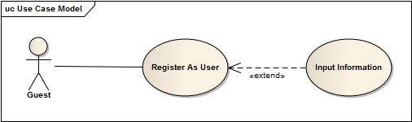

|  |  |  |
| --- | --- | --- |
| **Author** |  | |
| **Use Case Name** | Register As User | |
| **Actors** | Guest | |
| **Description** | Guest wants to register with the website to become a User member. | |
| **Requirements** | Guest provides Guest’s information | |
| **Pre-conditions** |  | |
| **Post-conditions** | Success: Guest creates a User account in this website  Fail: Refill information | |
| **Basic flow** | Actor Actions:  1. Actor clicks ‘Register’ link in Home page  3. Actor clicks on to Agree button.  5. Actor inputs register’s information, select ‘User’ radio button and click ‘Register’ button. [Alternative 1] | System Responses:  2. System redirects to Registration Policy page.  4. System redirects to Register page and displays Registration form with the following control :  - ‘UserName’ text field  - ‘Password’ text field  - ‘Confirm Password’ text field  - ‘Name’ text field  - ‘Address’ text field  - ‘Phone’ text field  - ‘Email’ text field  -- ‘Register’ button  - ‘Back to Home’ button  6. System checks the information  [Exception 1]  7. System inserts the account into database, show message: ‘Your account has been created!’ and then redirects to Login page. |
| **Alternative flow** | Actor Actions:  [Alternative 1]  1. Actor click ‘Back to Home’ button. | System Responses:  2. System returns to Home page. |
| **Exception flow** | Actor Actions:  [Exception 1]  1. Actor lefts ‘UserName’ text field blank.  2. UserName has already exists.  3. Actor lefts ‘Password’ text field blank.  4. Actor lefts ‘Confirm Password’ text field blank.  5. Password and confirm password don’t match.  6. Actor lefts ‘Name’ text field blank.  7. Actor lefts ‘Address’ text field blank.  8. Actor lefts ‘Phone’ text field blank.  9. Input phone not in numeric or phone length not in range 8 – 14 character.  10. Actor lefts ‘Email’ text field blank or input an invalid email address.  11. Actor left ‘Captcha’ text field blank or input an unmatch value. | System Responses:  System displays message to Actor :  - ‘UserName cannot be blank’.  - ‘This Username has already exist!’.  - ‘Password cannot be blank’’.  - ‘Confirm Password can’t be blank’.  - ‘Confirm password not match password.’  - ‘Name cannot be blank’.  - ‘Address cannot be blank’.  - ‘Phone is invalid’.  - ‘The phone number should be numeric only and must be between 8 and 14 digits’.  - ‘Email is invalid’. |

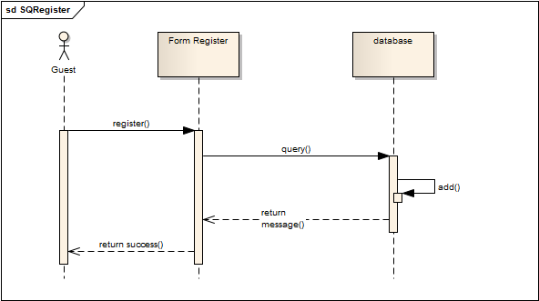

### Guest can login as User

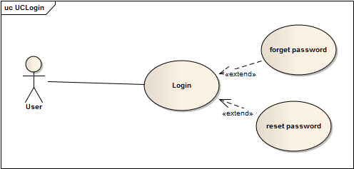

|  |  |  |
| --- | --- | --- |
| **Author** |  | |
| **Use Case Name** | Login To website | |
| **Actors** | User | |
| **Description** | User wants to login to website as User member. | |
| **Requirements** | Actor provides username and password | |
| **Pre-conditions** |  | |
| **Post-conditions** | Success: User logged in to website.  Fail: Refill information | |
| **Basic flow** | Actor Actions:  1. Actor go to Home page of website.  3. Actor inputs UserName and Password, then click the Login button. | System Responses:  2. System redirects to Home page and displays Login form on the left with the following control:  - ‘UserName’ text field  - ‘Password’ text field  - ‘Go’ button  4. System checks the information  [Exception 1]  5. System redirects to Actor’s Home page. |
| **Alternative flow** | Actor Actions:  [Alternative 2]  1. Actor click ‘OK’ button, inputs UserName and Password, then click the Login button.  [Alternative 1]  1. Actor click ‘Back to Home’ button. | System Responses:  2. System checks the information  [Exception 1]  3. System redirects to Actor’s Home page.  2. System returns to Home page. |
| **Exception flow** | Actor Actions:  [Exception 1]  1. Actor input invalid username and password. | System Responses:  - System redirect to Login page with the following controls:  - ‘UserName’ text field  - ‘Password’ text field  - ‘Login’ button. |

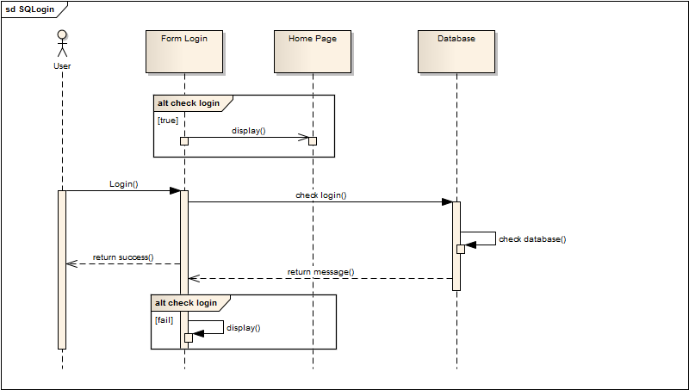

### Guest and user can view domain

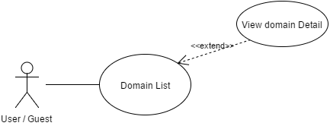

|  |  |  |
| --- | --- | --- |
| **Author** |  | |
| **Use Case Name** | View Domain | |
| **Actors** | Guest and user | |
| **Description** | Guest and user can view the domain page with list domain and domain information | |
| **Requirements** | Guest and user choose domain to view | |
| **Pre-conditions** |  | |
| **Post-conditions** | Success: Detail of domain will be show  Fail: Show 404 page | |
| **Basic flow** | Actor Actions:   1. Actor clicks ‘View Details’ button on List Domain Page. | System Response:  1. System displays information of domain by these control:  - Title label to display title of domain  - Image to display thumb image of domain  - Domain Description to display short description of domain  - Link go to domain detail page  - In domain detail page, the system will show all the service belong to domain  - Link back . Go to home page |
| **Alternative flow** |  |  |
| **Exceptions** |  |  |

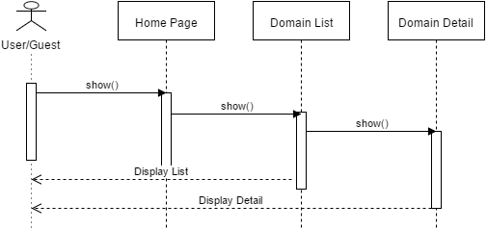

### Guest and user can view service

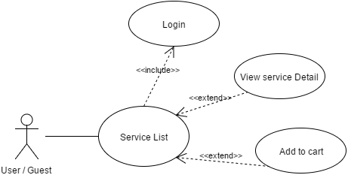

|  |  |  |
| --- | --- | --- |
| **Author** |  | |
| **Use Case Name** | View Service | |
| **Actors** | Guest and user | |
| **Description** | Guest and user can view the service page with list service and service information | |
| **Requirements** | Guest and user choose service to view | |
| **Pre-conditions** |  | |
| **Post-conditions** | Success: Detail of service will be show  Fail: Show 404 page | |
| **Basic flow** | Actor Actions:   1. Actor clicks ‘View Details’ button on List Service Page. | System Response:  1. System displays information of service by these control:  - Title label to display title of service  - Image to display thumb image of service  - Service Description to display short description of service  - Link go to service detail page  - In service detail page, the system will show all the service belong to service  - Price : price of service  - Link back . Go to home page |
| **Alternative flow** |  |  |
| **Exceptions** |  |  |

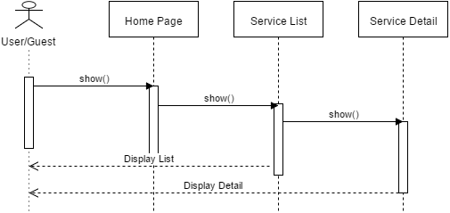

### Guest and user can view project

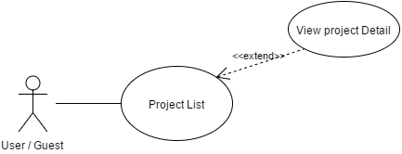

|  |  |  |
| --- | --- | --- |
| **Author** |  | |
| **Use Case Name** | View Project | |
| **Actors** | Guest and user | |
| **Description** | Guest and user can view the project page with list project and project information | |
| **Requirements** | Guest and user choose project to view | |
| **Pre-conditions** |  | |
| **Post-conditions** | Success: Detail of project will be show  Fail: Show 404 page | |
| **Basic flow** | Actor Actions:   1. Actor clicks ‘View Details’ button on List Project Page. | System Response:  1. System displays information of project by these control:  - Title label to display title of project  - Image to display thumb image of project  - Project Description to display short description of project  - Link go to project detail page  - In project detail page, the system will show all the project belong to project  - Price : price of project  - Link back . Go to home page |
| **Alternative flow** |  |  |
| **Exceptions** |  |  |

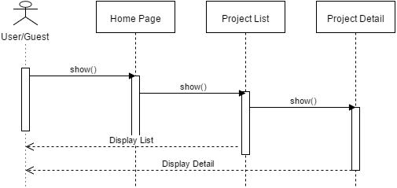

### Guest can send feedback to admin

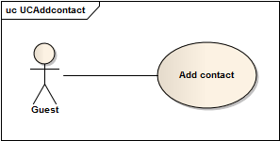

|  |  |  |
| --- | --- | --- |
| Author |  | |
| Use Case Name | Send feedback (Add contact) | |
| Actors | Guest | |
| Description | Actor wish to contact with Administrator | |
| Requirements |  | |
| Pre-conditions | Actor input full information with email address | |
| Post-conditions | Success: Guest’s information will show on View contact page.  Fail: Refill Information. | |
| Basic flow | Actor action:   1. Actor clicks Contact tab on Home page   3. Actor click ‘Send contact’ button | System Responses:   1. System redirects to this page and displays form for Actor to input contact’s information.   4. System update the contact information into database and then redirects to Actor Home page. |
| Alternative flow | Actor click ‘Cancel button | System clears all fields on Actor Home page. |
| Exception flow |  |  |

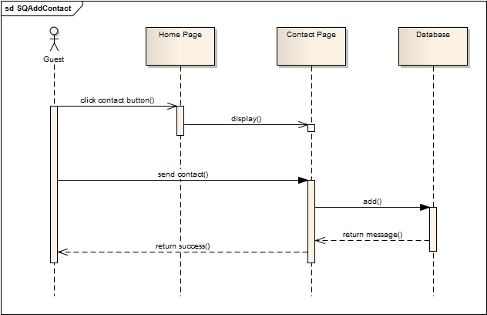

## User

### User can add service to cart

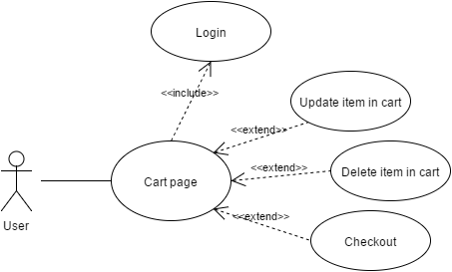

|  |  |  |
| --- | --- | --- |
| **Author** |  | |
| **Use Case Name** | Add Service to cart | |
| **Actors** | Customer | |
| **Description** | Customer wants to add service to cart | |
| **Requirements** | Actor click a add to cart button in service page | |
| **Pre-conditions** | Actor has logged in. | |
| **Post-conditions** | Success: The service add to cart successful  Fail: Display error message | |
| **Basic flow** | Actor Actions:  1. Actor clicks ‘Add to cart’ button on the service page.  2.Actor click ‘Update’ button on the cart page  3.Actor click ‘Delete’ button on the item | System Responses:  1. System redirect to cart page and show the cart information with the following controls:  - Item : Label  - Name of service : Link  - Service quantity : input  - Price : Label  - Total Price : Label  - Update : Button  - Delete : Button  - Check out : Button  - Back To Home : Button  2. System will be update all item in cart and reload page  3. System will be remove this item out of cart |
| **Alternative flow** | Actor Actions:  [Alternative 1]  1. Actor click ‘Back to Home’ button. | System Responses:  1. System returns to Actor Home page. |
| **Exception** | Actor Actions:  [Exception 1]  1. Actor lefts ‘Quantity’ text field blank.  2. Actor input not a number to ‘Quantity’ text field | System Responses:  System displays message to Actor :  - ‘Quantity cannot be blank’  - ‘Quantity must e a number’ |

### User can checkout

|  |  |  |
| --- | --- | --- |
| **Author** |  | |
| **Use Case Name** | Checkout | |
| **Actors** | Customer | |
| **Description** | Customer wants to checkout service on site | |
| **Requirements** | Actor click a link to checkout. | |
| **Pre-conditions** | Actor has logged in. | |
| **Post-conditions** | Success: Customer order service sucessfully  Fail: Refill Information. | |
| **Basic flow** | Actor Actions:  1. Actor clicks ‘Order’ button on the Actor Home page menu.  3. Actor inputs Recipient name, recipient address, contact number, note, delivery date, recipient DOB and click ‘Order’ button. [Alternative 1] | System Responses:  2. System redirect to Buy Service and show the Order services form with the following controls:  - ‘Recipient name’ text field.  - ‘Recipient address’ text field.  - ‘Contact number’ text field.  -‘Note’ text field.  -‘Delivery date’ datebox.  -‘Recipient DOB’ datebox.  - ‘Buy’ button.  - ‘Back to Home’ button.  4. System checks the information  [Exception 1].  5. System create Orders and show Payment form.  - ‘Customer name’ text field.  - ‘Pay’ button.  - ‘Back to Home’ button.  7. System checks the information  [Exception 2].  8. System checks payment information and show Success form. |
| **Alternative flow** | Actor Actions:  [Alternative 1]  1. Actor click ‘Back to Home’ button. | System Responses:  2. System returns to Actor Home page. |
| **Exception** | Actor Actions:  [Exception 1]  1. Actor lefts ‘Recipient name’ text field blank.  2. Actor lefts ‘Recipient Address’ text field blank.  3. Actor lefts ‘Contact Number’ text field blank.  4. Actor lefts ‘Note’ text field blank.  5. Actor lefts ‘Delivery Date’ datebox blank.  6. Actor lefts ‘Recipient DOB’ datebox blank. | System Responses:  System displays message to Actor :  - ‘Recipient name cannot be blank’’.  - ‘Recipient Address can’t be blank’.  - ‘Contact Number’ can’t be blank’.  - ‘Note cannot be blank’.  - ‘Delivery Date is invalid’.  - ‘Repicient DOB is invalid’. |

### User can view his/her profile

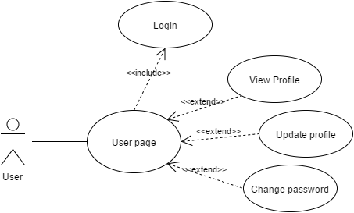

|  |  |  |
| --- | --- | --- |
| **Author** |  | |
| **Use Case Name** | View Profile | |
| **Actors** | User | |
| **Description** | User can view his / her profile information | |
| **Requirements** | Must be login and click a link in menu | |
| **Pre-conditions** |  | |
| **Post-conditions** | Success: Detail page will be show  Fail: Show 404 page | |
| **Basic flow** | Actor Actions:   1. Actor clicks ‘Profile’ link on menu.   2.Actor clicks ‘Change password’ link  3.Actor clicks ‘Edit profile’ link  4. User clicks ‘Logout; link | System Response:  1. System displays information of user by these control:  - Username : label  - Fullname : label  - Address : label  - Age : label  - Gender : label  - Email : label  - Mobile : label  - Change password : link  - Edit profile : link  - Back to home : link  2.System will redirect to change password page  3. System will redirect to edit profile page  4. System will clear all session and redirect to home page |
| **Alternative flow** | [Alternative 1]  1. Actor clicks on ‘Go to home’ link | System redirects to home page |
| **Exceptions** |  |  |

### User can change his/her profile



|  |  |  |
| --- | --- | --- |
| **Author** |  | |
| **Use Case Name** | Change Profile | |
| **Actors** | User | |
| **Description** | Change Profile | |
| **Requirements** |  | |
| **Pre-conditions** | Already login into the System as user | |
| **Post-conditions** | Success: Update user’s details into the database. | |
| **Basic flow** | Actor actions:  1. From ‘home or any’ page, actor clicks on to the ‘Change profile’ button  3. Actor:   * Inputs name into ‘CustomerName’ textfield. * Inputs address into ‘CustomerAddress’ textfield. * Inputs email into ‘CustomerEmail’ textfield. * Inputs phone into ‘Customerphone’ textfield.   Clicks on to ‘Add’ button to finish adding. [Alternative 1] | System response:  2. System redirects to ‘Change password’ page and display form with the following controls:  ‘Username’ label  ‘CustomerName’ Textfield  ‘CustomerAddress’ Textfield  ‘CustomerEmail’ Textfield  ‘CustomerPhone’ Textfield |
| **Alternative flow** | [Alternative 1]  1. Actor clicks on to ‘Cancel’ button | 1. System redirects to ‘View List of Customers’ page |
| **Exception flow** | [Exception 1]  1. Actor lefts ‘CustomerName’ textfield.  2. Actor lefts ‘CustomerAddress’ textfield.  3. Actor lefts ‘CustomerEmail’ textfield  4. 2. Actor lefts ‘CustomerPhone’ textfield | System displays a message to notice actor:  “CustomerName cannot be blank. Please input News name.”  “CustomerAddress cannot be blank. Please input address.”  “CustomerEmail cannot be blank. Please input email.”  “CustomerPhone cannot be blank. Please input phone and 10 or 11 digital.” |

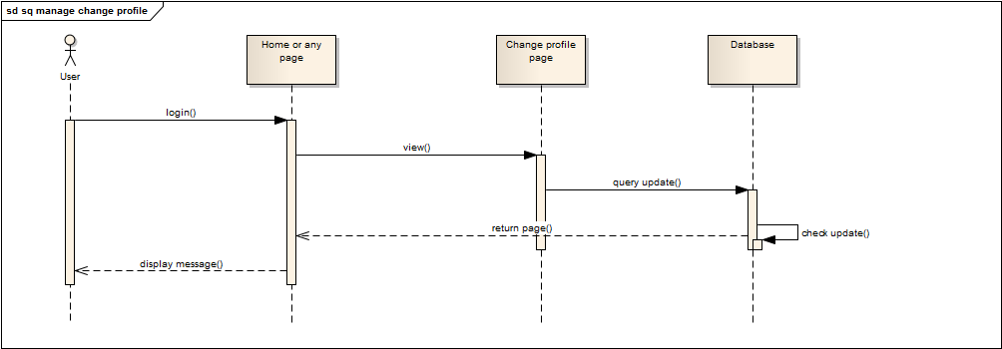

### User can change his/her password



|  |  |  |
| --- | --- | --- |
| **Author** |  | |
| **Use Case Name** | Change Password | |
| **Actors** | User | |
| **Description** | Change Password | |
| **Requirements** |  | |
| **Pre-conditions** | Already login into the System as user | |
| **Post-conditions** | Success: Update user’s password into the database. | |
| **Basic flow** | Actor actions:  1. From ‘home or any’ page, actor clicks on to the ‘Change word’ button  3. Actor:   * Inputs password into ‘old-password’ textfield. * Inputs new password into ‘New-password’ textfield. * Inputs pre-password into ‘pre-new-passowrd’ textfield.   Clicks on to ‘Add’ button to finish adding. [Alternative 1] | System response:  2. System redirects to ‘Change password’ page and display form with the following controls:  ‘user name’ Textfield  ‘old-password’ Textfield  ‘New-password’ Textfield  ‘pre-new-passowrd’ Textfield |
| **Alternative flow** | [Alternative 1]  1. Actor clicks on to ‘Cancel’ button | 1. System redirects to ‘View List of Customers’ page |
| **Exception flow** | [Exception 1]  1. Actor lefts ‘New-password’ textfield.  2. Actor lefts ‘pre-new-passowrd’ textfield. | System displays a message to notice actor:  “New-password cannot be blank. Please input News new password.”  “pre-new-passowrd cannot be blank. Please input pre-password.”  “New-password and pre-new-password is equal.” |

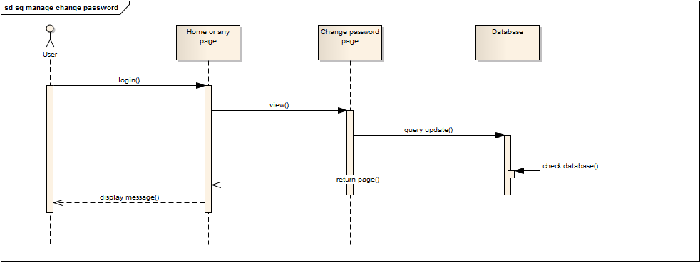

### User can view transaction history

|  |  |  |
| --- | --- | --- |
| **Author** |  | |
| **Use Case Name** | Can view transaction history | |
| **Actors** | User | |
| **Description** | User wants to view transaction history. | |
| **Requirements** |  | |
| **Pre-conditions** | Actor has logged in as User | |
| **Post-conditions** |  | |
| **Basic flow** | Actor Actions:  1. Actor clicks ‘Transaction History’ button in Profile page. | System Responses:  1.System redirects to Hostory page and show the list of transaction with many control :  - Name : label  - Price : label  - Time : label  - Detail : link  - Image : image |
| **Alternative flow** | 1 . Actor click ‘Detail’ link in transaction history page | 1 . System will redirect to history detail page will following control :  - Order Name : label  - Order Address : label  - Order Mobile : label  - Order Email : label  - Order Date : label  - Recipient Name : label  - Recipient Address : label  - Recipient Email : label  - Recipient Mobile : label  - Note : label  - Back : Button |
| **Exception** |  |  |

### User can cancel the order

|  |  |  |
| --- | --- | --- |
| **Author** |  | |
| **Use Case Name** | Can cancel the bill | |
| **Actors** | User | |
| **Description** | User wants to cancel the bill. | |
| **Requirements** |  | |
| **Pre-conditions** | Actor has logged in as User | |
| **Post-conditions** |  | |
| **Basic flow** | Actor Actions:  1. Actor clicks ‘Cancel’ button in ‘History Transaction’ page  2 . Actor clicks ‘Yes’ button in dialog | System Responses:  1.System will appearing the dialog to confirm :  ‘Are you sure you want to cancel this order ?’  With two button : Yes, No  2 . The bill will be cancel and save to database |
| **Alternative flow** |  |  |
| **Exception** |  |  |

## Admin

### Admin can manage user

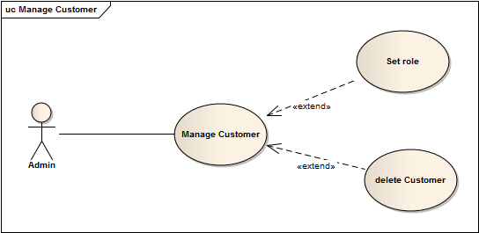

|  |  |  |
| --- | --- | --- |
| Author |  | |
| Use Case Name | Manager Customer | |
| Actors | Administrators | |
| Description | View list of Customers | |
| Requirements |  | |
| Pre-conditions | Already login into the System as Administrator | |
| Post-conditions | Success: View list of Customers | |
| Basic flow | Actor actions:   1. From ‘Admin’ page, actor clicks on to the ‘Manager of Customer’ button. 2. Clicks on to ‘Save’ button to finish adding. [Alternative 1] | System response:  2. System redirects to ‘List of News’ page and display list of all of News in table form with control :  ‘CustomerID’ label  ‘Username’ label  ‘CustomerName’ label  ‘CustomerAddress’ label  ‘CustomerEmail’ label  ‘CustomerRole’ label  ‘CustomerPhone’ label  ‘Role’ Combobox  ‘Delete’ button  ‘Save’ button |
| Alternative flow | [Alternative 1]  1. Actor clicks on to ‘Cancel’ button | 1. System redirects to ‘View List of Customers’ page |
| Exception flow |  |  |

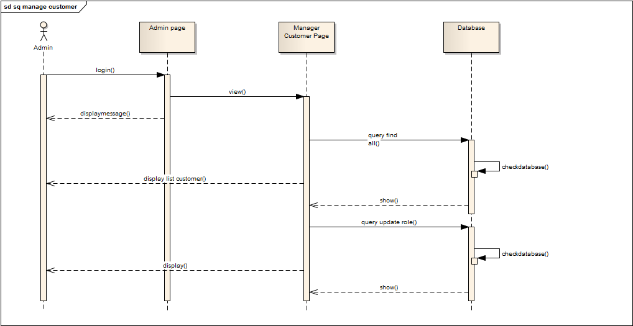

### Admin can manage domain

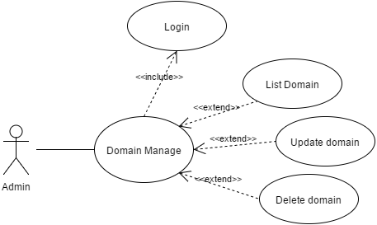

|  |  |  |
| --- | --- | --- |
| Author |  | |
| Use Case Name | Manager Domain | |
| Actors | Administrators | |
| Description | Actor wish to view list of domain, add new domain, update domain and delete domain. | |
| Requirements |  | |
| Pre-conditions | Actor has logged in as Administrator | |
| Post-conditions | Success: List of domain will be show  Error : 404 page will be show | |
| Basic flow | Actor Actions:  1. Actor clicks ‘Manage Domain’ link on Admin page | System Responses:  1. System redirects to list domain page and displays list for actor.  List will show all information of domain.  Such as :   * Domain Name : Label * Domain Description : Label * Count of service : Label * Update : Button * AddNew : Button * Delete : Button * View detail : Button |
| Alternative flow | Actor Actions:  1 . Actor clicks View detail button on list  2. Actor click add new button on list  3. Actor clicks Save button in Add new page  4. Actor clicks Update button on list  5. Actor clicks Save button in Update page  6 . Actor clicks Delete button  7. Actor click ‘Yes’ button in dialog | System Responses:  1. System show detail page with full information of domain with the following controls :  - Domain Name : Label   * Domain * Description : Label * Count of service : Label * Update : Button * AddNew : Button * Delete : Button   2. System will redirect to addnew page for accept input of administrator will following controls :  - Domain name : input text  - Domain Description : textarea  - Addnew : button  - Cancel : button  3. System will validation the data input by Admin.  If data valid, the system will be save new data into database  If error : system will show message to notify.  If all transaction is successful, the data will be update and redirect to list domain page  4. System will redirect to update page for accept input of administrator will following controls :  - Domain name : input text  - Domain Description : textarea  - Update : button  - Cancel : button  5. System will validation the data input by Admin.  If data valid, the system will be save new data into database  If error : system will show message to notify.  6 . System show popup message :”Do you want to remove this item ? “. With Yes and No button  7 . System delete contact from database then display message ‘Your item has been deleted successful’. |
| Exception flow | Actor Actions:  [Alternative 1]  1 . Actor click ‘No’ button.  2. Actor lefts ‘Domain Name’ text field blank.  3 . Actor lefts ‘Domain Description’ text field blank  4 . Actor click Cancel button | System Responses:  1 . System returns to Account List page.  2. System will be show message : ‘Domain name can not be null’  3. System will be show message : ‘Domain name can not be null’  4. System will redirect to domain list |

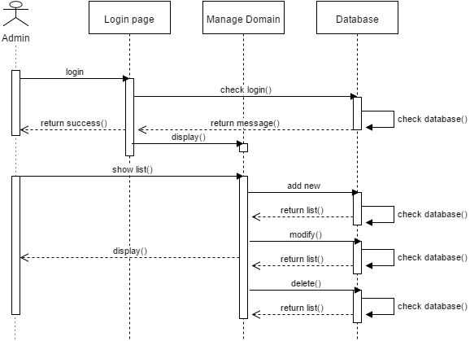

### Admin can manage services

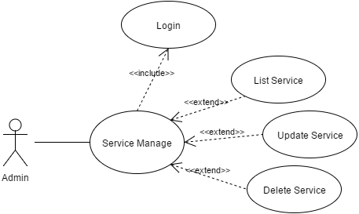

|  |  |  |
| --- | --- | --- |
| Author |  | |
| Use Case Name | Manager Service | |
| Actors | Administrators | |
| Description | Actor wish to view list of service, add new service, update service and delete service. | |
| Requirements |  | |
| Pre-conditions | Actor has logged in as Administrator | |
| Post-conditions | Success: List of service will be show  Error : 404 page will be show | |
| Basic flow | Actor Actions:  1. Actor clicks ‘Manage Service’ link on Admin page | System Responses:  1. System redirects to list service page and displays list for actor.  List will show all information of service.  Such as :   * Service Name : Label * Service Description : Label * Count of service : Label * Domain : Dropdown * Update : Button * AddNew : Button * Delete : Button * View detail : Button |
| Alternative flow | Actor Actions:  1 . Actor clicks View detail button on list  2. Actor click add new button on list  3. Actor clicks Save button in Add new page  4. Actor clicks Update button on list  5. Actor clicks Save button in Update page  6 . Actor clicks Delete button  7. Actor click ‘Yes’ button in dialog | System Responses:  1. System show detail page with full information of service with the following controls :  - Service Name : Label   * Service Description : Label * Count of service : Label * Domain : Dropdown * Price : Label * Update : Button * AddNew : Button * Delete : Button   2. System will redirect to addnew page for accept input of administrator will following controls :  - Service name : input text  - Service Description : textarea  - Domain : Dropdown  - Price : input text  - Addnew : button  - Cancel : button  3. System will validation the data input by Admin.  If data valid, the system will be save new data into database  If error : system will show message to notify.  If all transaction is successful, the data will be update and redirect to list service page  4. System will redirect to update page for accept input of administrator will following controls :  - Service name : input text  - Service Description : textarea  - Domain : Dropdown  - Price : Label  - Update : button  - Cancel : button  5. System will validation the data input by Admin.  If data valid, the system will be save new data into database  If error : system will show message to notify.  6 . System show popup message :”Do you want to remove this item ? “. With Yes and No button  7 . System delete contact from database then display message ‘Your item has been deleted successful’. |
| Exception flow | Actor Actions:  [Alternative 1]  1 . Actor click ‘No’ button.  2. Actor lefts ‘Service Name’ text field blank.  3 . Actor lefts ‘Service Description’ text field blank  4. Actor not select ‘Domain’ dropdown  5 . Actor lefts ‘Service Price’ text field blank  6 . Actor click Cancel button | System Responses:  1 . System returns to Account List page.  2. System will be show message : ‘Service name can not be null’  3. System will be show message : ‘Service name can not be null’  4. System will be show message : ‘Please select domain’  5. System will be show message : ‘Service price can not be empty’  6. System will redirect to service list |

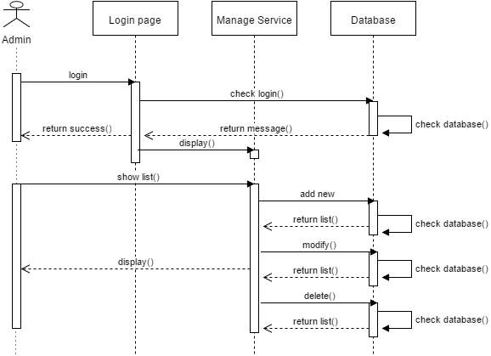

### Admin can manage Project

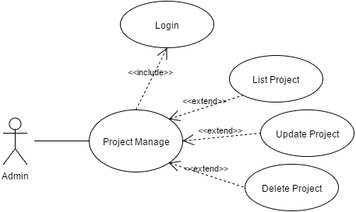

|  |  |  |
| --- | --- | --- |
| Author |  | |
| Use Case Name | Manager Project | |
| Actors | Administrators | |
| Description | Actor wish to view list of project, add new project, update project and delete project. | |
| Requirements |  | |
| Pre-conditions | Actor has logged in as Administrator | |
| Post-conditions | Success: List of project will be show  Error : 404 page will be show | |
| Basic flow | Actor Actions:  1. Actor clicks ‘Manage Project’ link on Admin page | System Responses:  1. System redirects to list project page and displays list for actor.  List will show all information of project.  Such as :   * Project Name : Label * Project Description : Label * Count of project : Label * Domain : Dropdown * Update : Button * AddNew : Button * Delete : Button * View detail : Button |
| Alternative flow | Actor Actions:  1 . Actor clicks View detail button on list  2. Actor click add new button on list  3. Actor clicks Save button in Add new page  4. Actor clicks Update button on list  5. Actor clicks Save button in Update page  6 . Actor clicks Delete button  7. Actor click ‘Yes’ button in dialog | System Responses:  1. System show detail page with full information of project with the following controls :  - Project Name : Label   * Project Description : Label * Count of project : Label * Domain : Dropdown * Price : Label * Update : Button * AddNew : Button * Delete : Button   2. System will redirect to addnew page for accept input of administrator will following controls :  - Project name : input text  - Project Description : textarea  - Domain : Dropdown  - Price : input text  - Addnew : button  - Cancel : button  3. System will validation the data input by Admin.  If data valid, the system will be save new data into database  If error : system will show message to notify.  If all transaction is successful, the data will be update and redirect to list project page  4. System will redirect to update page for accept input of administrator will following controls :  - Project name : input text  - Project Description : textarea  - Domain : Dropdown  - Price : Label  - Update : button  - Cancel : button  5. System will validation the data input by Admin.  If data valid, the system will be save new data into database  If error : system will show message to notify.  6 . System show popup message :”Do you want to remove this item ? “. With Yes and No button  7 . System delete contact from database then display message ‘Your item has been deleted successful’. |
| Exception flow | Actor Actions:  [Alternative 1]  1 . Actor click ‘No’ button.  2. Actor lefts ‘Project Name’ text field blank.  3 . Actor lefts ‘Project Description’ text field blank  4. Actor not select ‘Domain’ dropdown  5 . Actor lefts ‘Project Price’ text field blank  6 . Actor click Cancel button | System Responses:  1 . System returns to Account List page.  2. System will be show message : ‘Project name can not be null’  3. System will be show message : ‘Project name can not be null’  4. System will be show message : ‘Please select domain’  5. System will be show message : ‘Project price can not be empty’  6. System will redirect to project list |

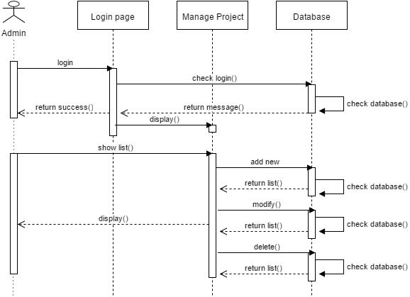

### Admin can manage feedback

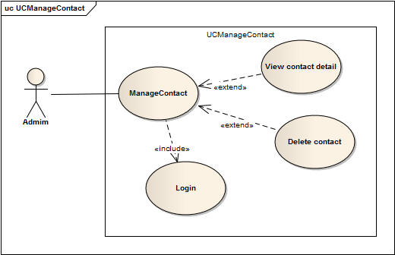

|  |  |  |
| --- | --- | --- |
| Author |  | |
| Use Case Name | Manager Contact | |
| Actors | Administrators | |
| Description | Actor wish to view list of contacts. | |
| Requirements |  | |
| Pre-conditions | Actor has logged in as Administrator | |
| Post-conditions | Success: List of contacts show successful | |
| Basic flow | Actor Actions:  1. Actor clicks ‘Managing Comments’ button on Admin page | System Responses:  2. System redirects to View List of Comments page and displays form for Actor :  -‘ID’ label  -‘User’s name’ label  -‘User’s email’ label  -‘Action’ button |
| Alternative flow | Actor Actions:   1. Actor clicks View detail button on View list of contact page   3. Actor clicks Delete button on View list of contact page   1. Actor clicks Yes button | System Responses:   1. System show detail page of contact with full information from user.   4. System show popup message :”Do you want to remove this contact ? “. With Yes and No button  6. System delete contact from database then display message ‘Your contact has been deleted successful’. |
| Exception flow |  |  |

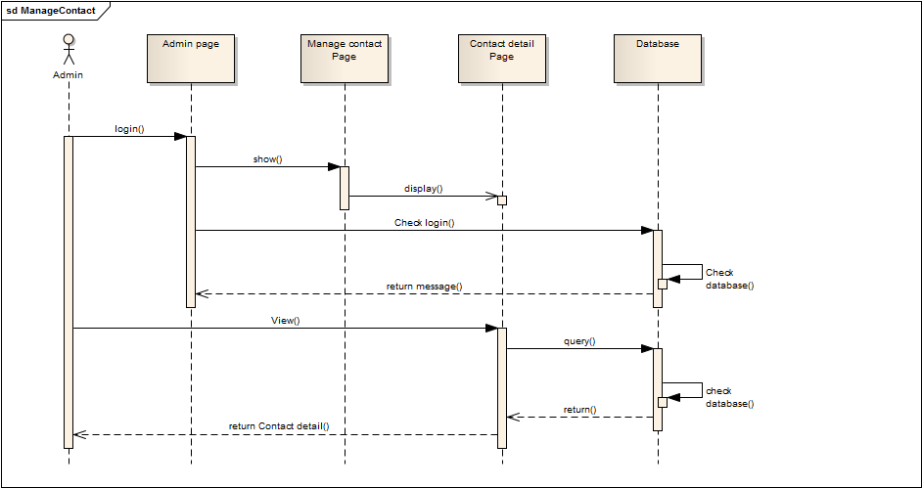

### Admin can manage bill

|  |  |  |
| --- | --- | --- |
| Author |  | |
| Use Case Name | Manager Bill | |
| Actors | Administrators | |
| Description | Actor wish to view list of bill, detail bill and change bill status | |
| Requirements |  | |
| Pre-conditions | Actor has logged in as Administrator | |
| Post-conditions | Success: List of bill will be show  Error : 404 page will be show | |
| Basic flow | Actor Actions:  1. Actor clicks ‘Manage Bill’ link on Admin page | System Responses:  1. System redirects to list bill page and displays list for actor.  List will show all information of Bill.  Such as :  - Order Name : label  - Order Address : label  - Order Mobile : label  - Order Date : label  - Recipient Name : label  - Recipient Address : label  - Recipient Mobile : label  - Note : label  - Detail : button  - Change status : Dropdown |
| Alternative flow | Actor Actions:  1 . Actor clicks View detail button on list  2. Actor change status | System Responses:  1. System show detail page with full information of project with the following controls :  Order Name : label  - Order Address : label  - Order Mobile : label  - Order Date : label  - Recipient Name : label  - Recipient Address : label  - Recipient Mobile : label  - Note : label  2. System will change status of bill and redirect to list Bill page |
| Exception flow |  |  |

### Admin can view system statitics

|  |  |  |
| --- | --- | --- |
| **Author** |  | |
| **Use Case Name** | Can view system statitics | |
| **Actors** | Admin | |
| **Description** | Admin wants to view system statitics. | |
| **Requirements** |  | |
| **Pre-conditions** | Actor has logged in as Admin | |
| **Post-conditions** |  | |
| **Basic flow** | Actor Actions:  1. Actor clicks ‘System statitics’ link in menu.  2 . Actor clicks ‘Back’ button in menu | System Responses:  1.System redirects to System Statitics page and show the statitis with many control :  - Total Domain : label  - Total Project : label  - Total Service : label  - Total User : label  - Total Bill : label  - Total images : label  - Total feedback : label  - Back : button  2. The system will redirect to Admin Home page |
| **Alternative flow** |  |  |
| **Exception** |  |  |

### Admin can change password

|  |  |  |
| --- | --- | --- |
| 1. **Author** |  | |
| **Use case name** | Change Password | |
| **Actors** | Administrator | |
| **Description** | Change Password | |
| **Requirements** | Actor provides Username and Password | |
| **Pre-conditions** | Actor has logged in as Administrator | |
| **Post-conditions** | Success: The password of Administrator has changed. | |
| **Basic flow** | Actor actions:  1. From ‘Admin’ page, actor clicks on to the ‘Change Password’ button.  3. Actor clicks on to ‘Save’ button to finish adding. [Alternative 1] | System response:  2. System redirects to ‘Change Password’ page and display form with the following controls:  ‘Old Password’ textfield.  ‘New Password’ textfield.  ‘Confirm New Password’ textfield.  ‘Save’ button.  4. System checks input information.  [Exception 1]  5. System adds new Administrator into the database. |
| **Alternative flow** | [Alternative 1]  1. Actor clicks on to ‘Admin Home Page’ button. | 2. System redirects to ‘Admin’ page. |
| **Exception** | [Exception 1]  1. Actor lefts ‘Old Password’ textfield.  2. Actor lefts ‘New Password’ textfield.  3. Actor lefts ‘Confirm New Password’ textfield.  4. ‘New Password’ textfield is not same as ‘Confirm New Password’ textfield. | System displays a message to notice actor:  “Old Password cannot be blank. Please input Old Password.”  “New Password cannot be blank. Please input New Password.”  “Confirm New Password cannot be blank. Please input Confirm Password.”  “New Password and Confirm New Password must be same.” |

# Entity Relationship Diagram (ERD)

## Conceptual

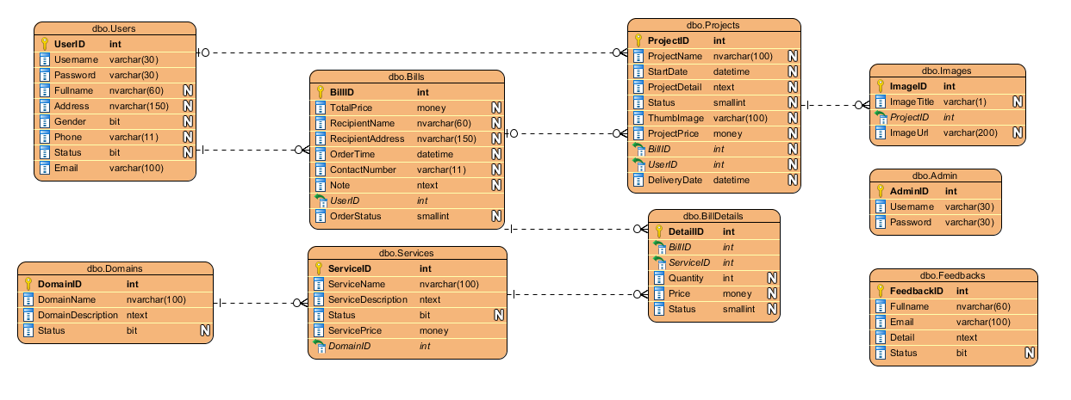

## Entity

### Admin

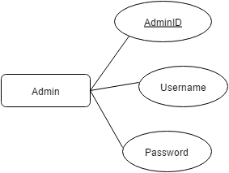

### Feedbacks

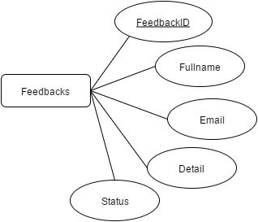

### Domains

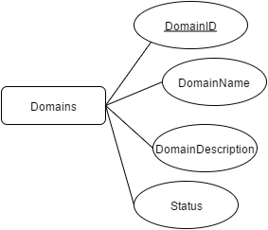

### Services

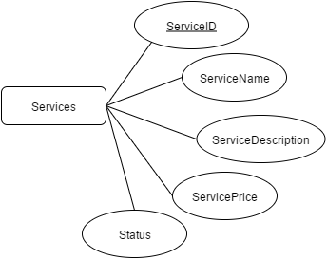

### Projects

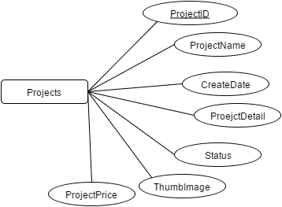

### Images

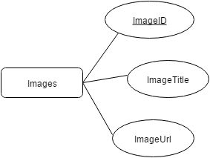

### Users

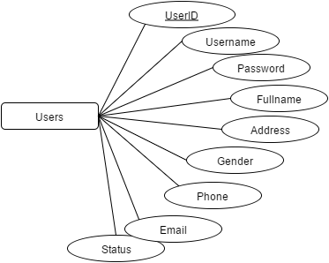

### Bills

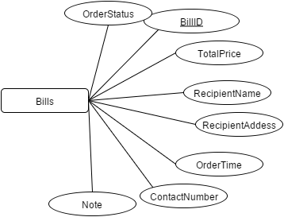

### BillDetails

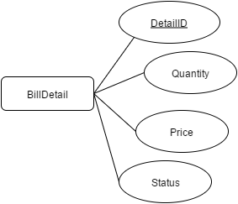

### FAQ

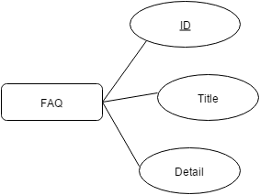

# Task Sheet

|  |  |  |  |  |  |
| --- | --- | --- | --- | --- | --- |
| Members | | Task | Date | | Status |
| No | Full Name |  | Start Date | Date Finish |  |
| 1. |  | Joint working | 3/8/2015 | 6/8/2015 | Completed |
| 2. |  | Joint working | Completed |
| 3. |  | Joint working | Completed |
| Leader | | | Faculty | | |
|  | | |  | | |
|  | | |  | | |

**REVIEW 3**

# Database Relationship Diagram

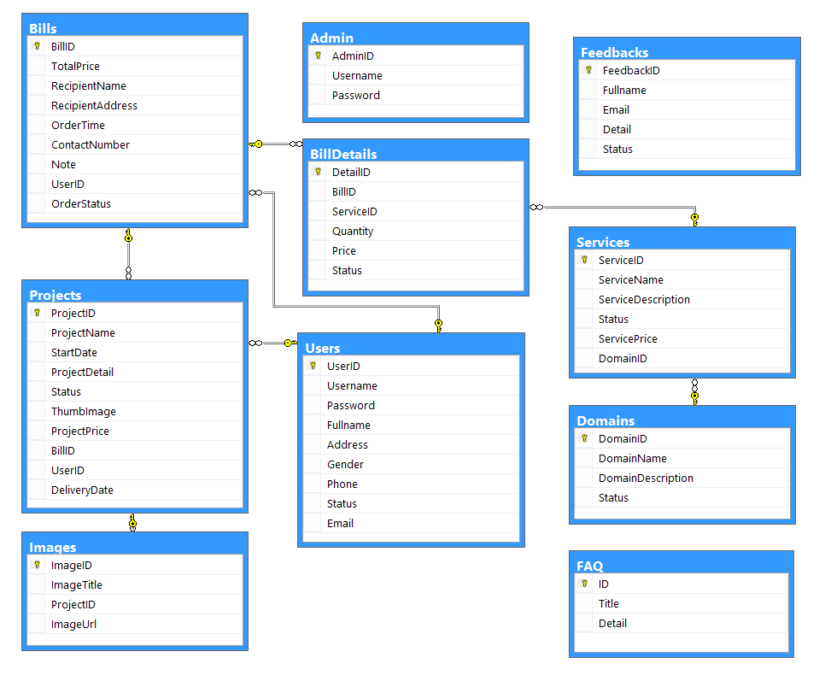

# Table Definition

## Admin

|  |  |  |  |  |
| --- | --- | --- | --- | --- |
| **Admin Table** | | | | |
| **Column Name** | **Data Type** | **Length** | **Allow Nulls** | **Description** |
| AdminID | Int, Identity(1,1), PK |  | 🞎 | Admin ID |
| Username | Varchar | 30 | 🞎 | Username |
| Password | Varchar | 30 | 🞎 | Password |

**Contrainst:**

|  |  |  |  |
| --- | --- | --- | --- |
| **Name** | **Add** | **Delete** | **Update** |
| Admin | + | - | + |

## Projects

|  |  |  |  |  |
| --- | --- | --- | --- | --- |
| **Projects Table** | | | | |
| **Column Name** | **Data Type** | **Length** | **Allow Nulls** | **Description** |
| ProjectID | Int, Identity(1,1), PK |  | 🞎 | Project ID |
| ProjectName | Nvarchar | 100 | 🞎 | Name of project |
| StartDate | Datetime |  | 🞎 | Date Create |
| DeliveryDate | Datetime |  | 🞎 | Delivery Date |
| ProjectDetail | Ntext |  | 🞎 | Project Detail |
| Status | Smallint |  | 🞎 | Status |
| ThumbImage | Varchar | 100 | 🞎 | Thumb Image |
| ProjectPrice | Money |  | 🞎 | Project Price |
| BillID | Int, FK |  | 🞎 | Bill ID |
| UserID | Int, FK |  | 🞎 | User ID |

**Contrainst:**

|  |  |  |  |
| --- | --- | --- | --- |
| **Name** | **Add** | **Delete** | **Update** |
| Project | + | + | + |

## Feedbacks

|  |  |  |  |  |
| --- | --- | --- | --- | --- |
| **Feedbacks Table** | | | | |
| **Column Name** | **Data Type** | **Length** | **Allow Nulls** | **Description** |
| FeedbackID | Int, Identity(1,1), PK |  | 🞎 | Feedback ID |
| Fullname | Nvarchar | 60 | 🞎 | Sender Fullname |
| Email | Varchar | 100 | 🞎 | Sender Email |
| Detail | Ntext |  | 🞎 | Feedback Detail |
| Status | Bit |  | 🞎 | Feedback Status |

**Contrainst:**

|  |  |  |  |
| --- | --- | --- | --- |
| **Name** | **Add** | **Delete** | **Update** |
| Feedback | + | + | - |

## Domains

|  |  |  |  |  |
| --- | --- | --- | --- | --- |
| **Domains Table** | | | | |
| **Column Name** | **Data Type** | **Length** | **Allow Nulls** | **Description** |
| DomainID | Int, Identity(1,1), PK |  | 🞎 | Domain ID |
| DomainName | Nvarchar | 100 | 🞎 | Domain Name |
| DomainDescription | Ntext |  | 🞎 | Domain Description |
| Status | Bit |  | 🞎 | Domain Status |

**Contrainst:**

|  |  |  |  |
| --- | --- | --- | --- |
| **Name** | **Add** | **Delete** | **Update** |
| Domains | + | + | + |

## Services

|  |  |  |  |  |
| --- | --- | --- | --- | --- |
| **Services Table** | | | | |
| **Column Name** | **Data Type** | **Length** | **Allow Nulls** | **Description** |
| ServiceID | Int, Identity(1,1), PK |  | 🞎 | Service ID |
| ServiceName | Nvarchar | 100 | 🞎 | Service name |
| ServiceDescription | Ntext |  | 🞎 | Service description |
| Status | Bit |  | 🞎 | Service status |
| ServicePrice | money |  | 🞎 | Service price |
| DomainID | Int, FK |  | 🞎 | Domain ID |

**Contrainst:**

|  |  |  |  |
| --- | --- | --- | --- |
| **Name** | **Add** | **Delete** | **Update** |
| Services | + | + | + |

## Users

|  |  |  |  |  |
| --- | --- | --- | --- | --- |
| **Users Table** | | | | |
| **Column Name** | **Data Type** | **Length** | **Allow Nulls** | **Description** |
| UserID | Int, Identity(1,1), PK |  | 🞎 | User ID |
| Username | Varchar | 30 | 🞎 | Username |
| Password | Varchar | 30 | 🞎 | Password |
| Fullname | Nvarchar | 60 | 🞎 | User Full name |
| Address | Nvarchar | 150 | 🞎 | User Address |
| Gender | Bit |  | 🞎 | User Gender |
| Phone | Varchar | 11 | 🞎 | User Phone |
| Status | Bit |  | 🞎 | Status |
| Email | Varchar | 100 | 🞎 | User Email |

**Contrainst:**

|  |  |  |  |
| --- | --- | --- | --- |
| **Name** | **Add** | **Delete** | **Update** |
| Users | + | + | + |

## Bills

|  |  |  |  |  |
| --- | --- | --- | --- | --- |
| **Bill Table** | | | | |
| **Column Name** | **Data Type** | **Length** | **Allow Nulls** | **Description** |
| BillID | Int, Identity(1,1), PK |  | 🞎 | Bill ID |
| TotalPrice | Money |  | 🞎 | Bill Total Price |
| RecipientName | Nvarchar | 60 | 🞎 | Recipient Name |
| RecipientAddress | Nvarchar | 150 | 🞎 | Recipient Address |
| OrderTime | Datetime |  | 🞎 | Order time |
| ContactNumber | Varchar | 11 | 🞎 | Contact number |
| Note | Ntext |  | 🞎 | Note |
| UserID | Int, FK |  | 🞎 | User ID |
| OrderStatus | Smallint |  | 🞎 | Order Status |

**Contrainst:**

|  |  |  |  |
| --- | --- | --- | --- |
| **Name** | **Add** | **Delete** | **Update** |
| Bill | + | - | - |

## BillDetails

|  |  |  |  |  |
| --- | --- | --- | --- | --- |
| **BillDetails Table** | | | | |
| **Column Name** | **Data Type** | **Length** | **Allow Nulls** | **Description** |
| DetailID | Int, Identity(1,1), PK |  | 🞎 | Bill Detail ID |
| BillID | Int, FK |  | 🞎 | Bill ID |
| ServiceID | Int, FK |  | 🞎 | Service ID |
| Quantity | Int |  | 🞎 | Service Quantity |
| Price | Money |  | 🞎 | Service Price |
| Status | Smallint |  | 🞎 | Bill Detail Status |

**Contrainst:**

|  |  |  |  |
| --- | --- | --- | --- |
| **Name** | **Add** | **Delete** | **Update** |
| BillDetail | + | - | - |

# Sitemap

## Home Site

Home Page

Login

Register

Service

My Account

Profile

Edit Profile

Change Pass

Search

Project

FeedBack

Domain

Checkout

Cart

Logout

FAQ

About Us

## Admin Site

Login

Admin Home

List Customer

Detail

Delete

List Domain

List feedback

List Bill

Add new

Update

Delete

List Service

List Project

List FAQ

System Statitics

# GUI Design

## Home Site

* + 1. Home

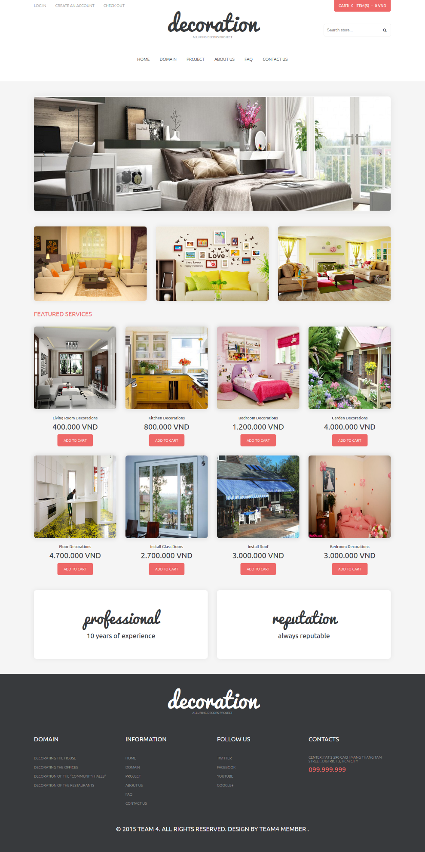

* + 1. Register

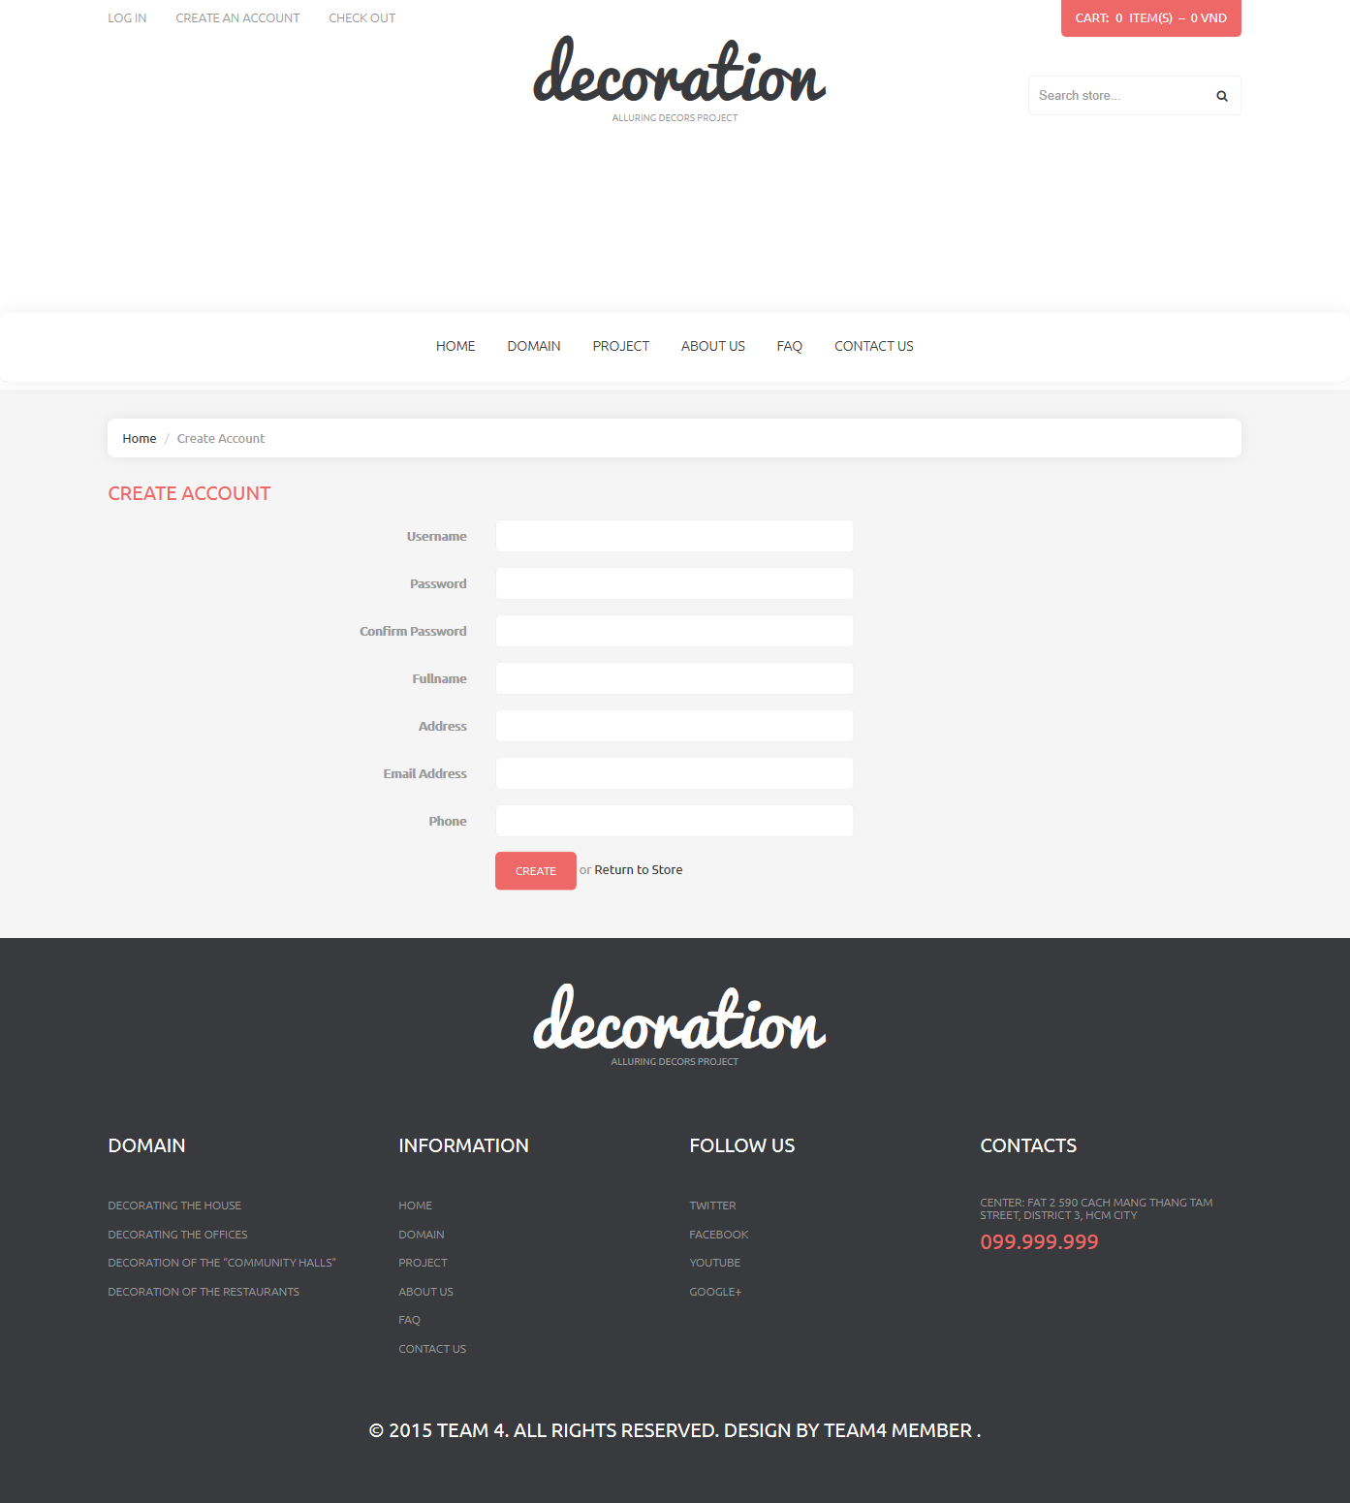

|  |  |  |  |  |  |  |
| --- | --- | --- | --- | --- | --- | --- |
| **No.** | **Name** | **Type** | **Validation** | **Event** | **Description** | **Status** |
| 1 | txtUsername | Text field | Required |  | Username |  |
| 2 | txtPassword | Text field | Required |  | Password |  |
| 3 | txtConfirm | Button | Required |  | Customer Confirm password |  |
| 4 | txtFullname | Checkbox | Required |  | Customer Fullname |  |
| 5 | txtAddress | Label | Required |  | Customer Address |  |
| 6 | txtMail | Label | Required |  | Customer Mail |  |
| 7 | txtPhone | Label | Required |  | Customer Phone |  |
| 8 | btnRegister | Button |  | Click | Click to register new account |  |

* + 1. Login

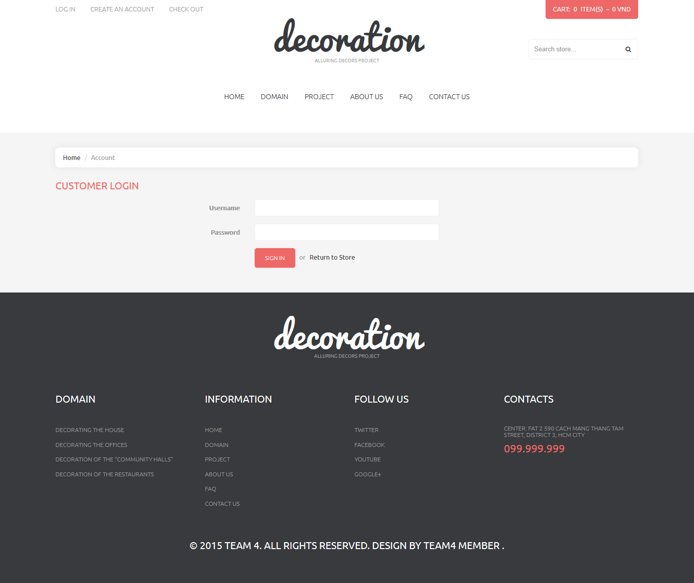

|  |  |  |  |  |  |  |
| --- | --- | --- | --- | --- | --- | --- |
| **No.** | **Name** | **Type** | **Validation** | **Event** | **Description** | **Status** |
| 1 | txtUsername | Text field | Required |  | Username |  |
| 2 | txtPassword | Text field | Required |  | Password |  |
| 3 | btnSignin | Button |  | Click | Login to customer |  |

* + 1. Domain

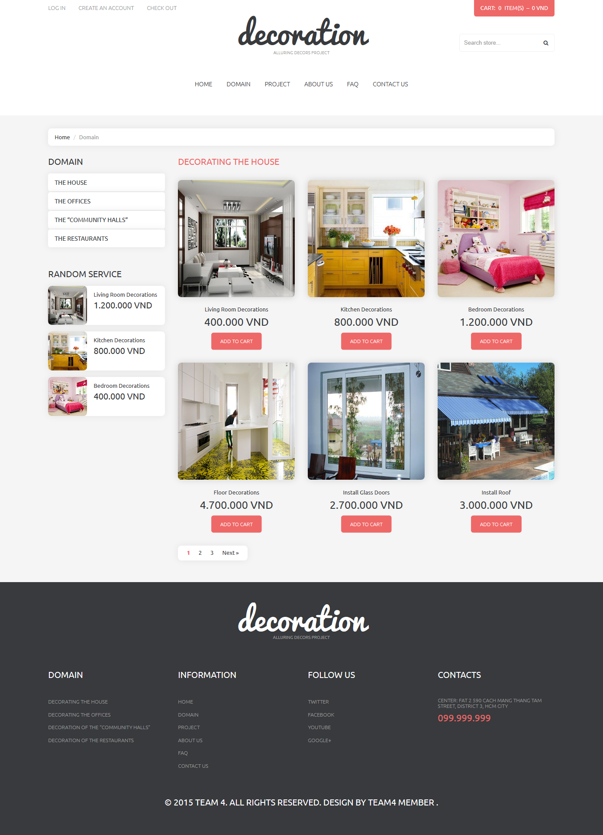

|  |  |  |  |  |  |  |
| --- | --- | --- | --- | --- | --- | --- |
| **No.** | **Name** | **Type** | **Validation** | **Event** | **Description** | **Status** |
| 1 | lbDomain | Link |  | Click | Go to domain page |  |
| 2 | gridService | List |  |  | List service belong to the domain |  |
| 3 | lbPaging | Paging |  | Click | Next and prev page |  |
| 4 | Home | Link |  | Click | Back to home |  |

* + 1. About Us

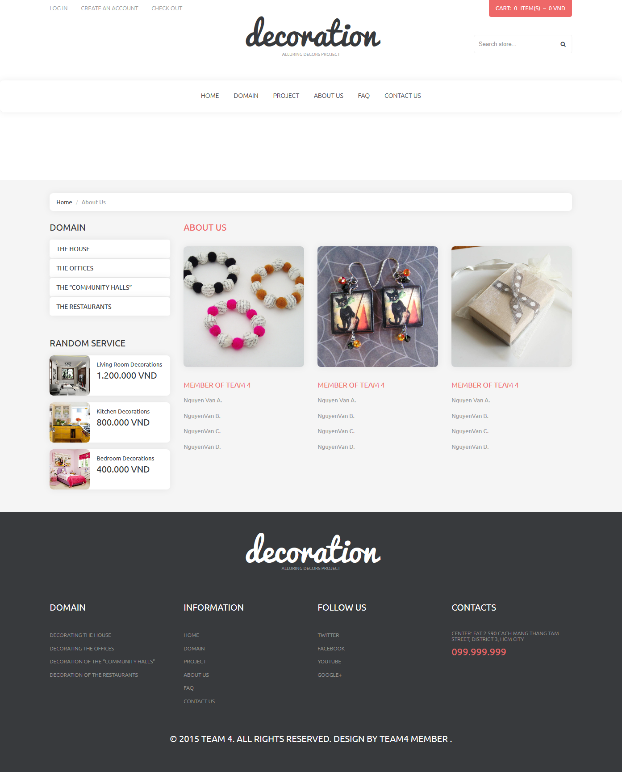

|  |  |  |  |  |  |  |
| --- | --- | --- | --- | --- | --- | --- |
| **No.** | **Name** | **Type** | **Validation** | **Event** | **Description** | **Status** |
| 1 | lbHome | Link |  | Click | Back to Home |  |

* + 1. Contact

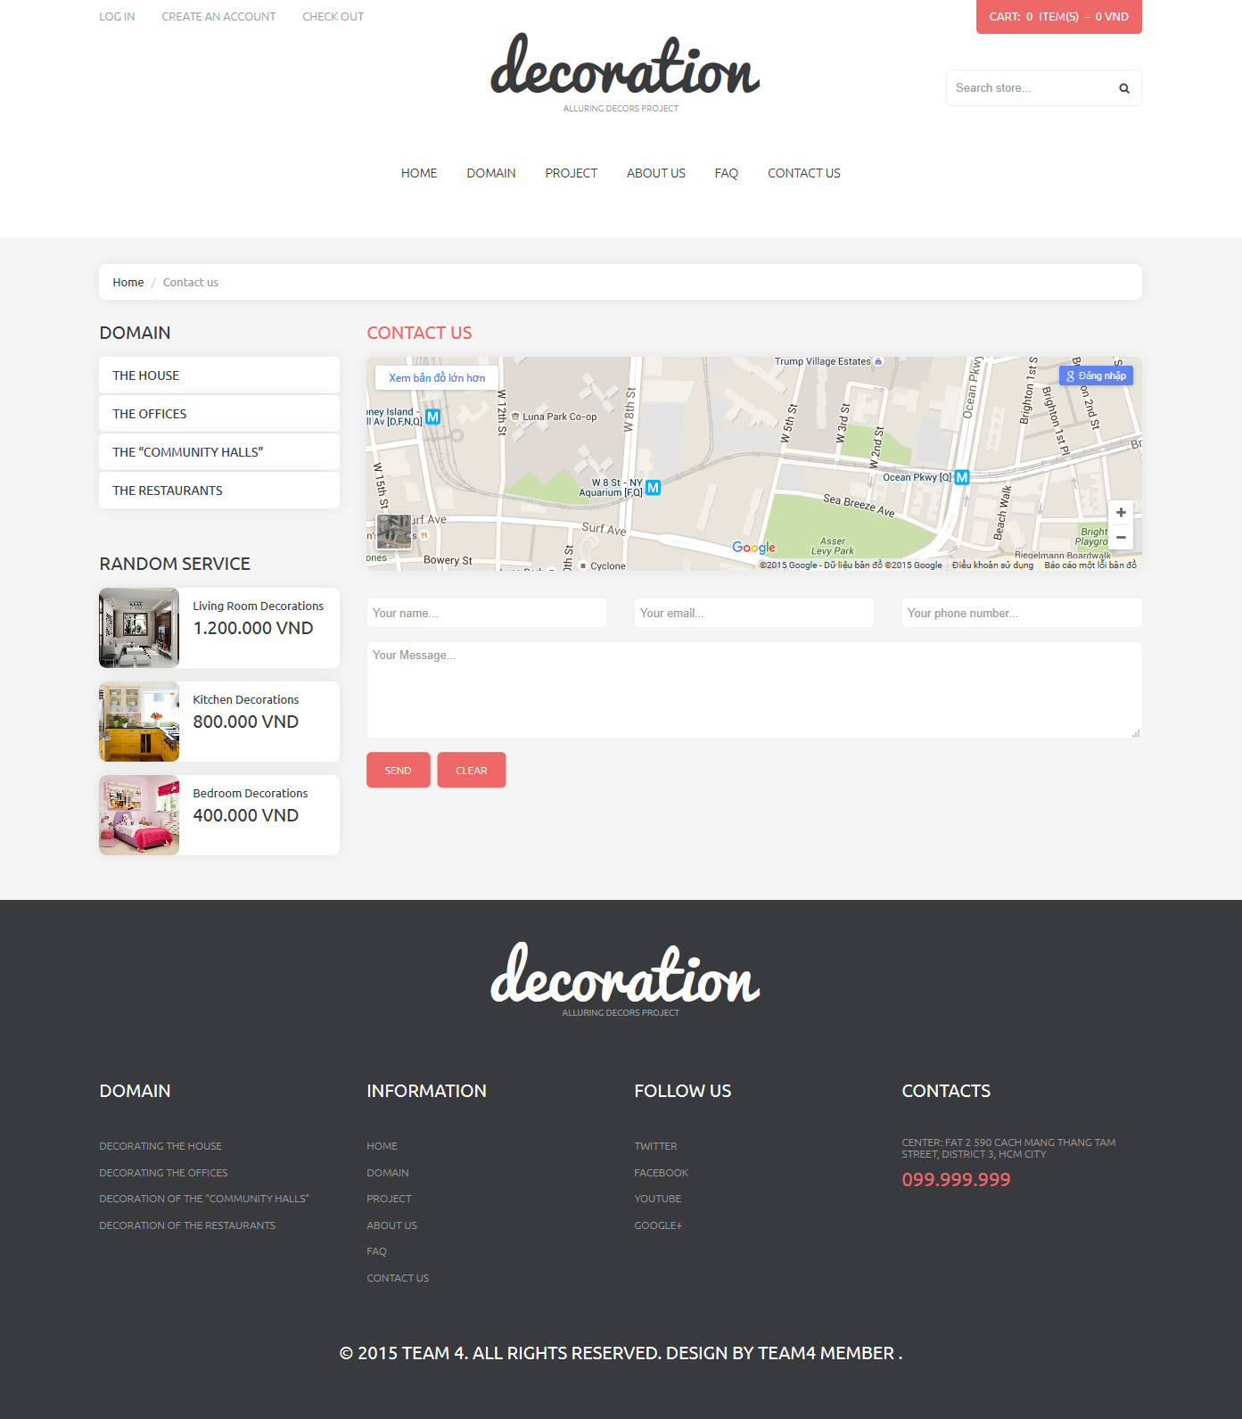

|  |  |  |  |  |  |  |
| --- | --- | --- | --- | --- | --- | --- |
| **No.** | **Name** | **Type** | **Validation** | **Event** | **Description** | **Status** |
| 1 | txtName | Text field | Required |  | Customer name |  |
| 2 | txtMail | Text field | Required |  | Customer mail |  |
| 3 | txtPhone | Text field | Required | Click | Customer Phone |  |
| 4 | txtDetail | Textarea | Required |  | Feedback detail |  |
| 5 | btnSend | Button |  | Click | Send feedback to admin |  |
| 6 | btnClear | Button |  | Click | Clear form |  |

* + 1. Search page

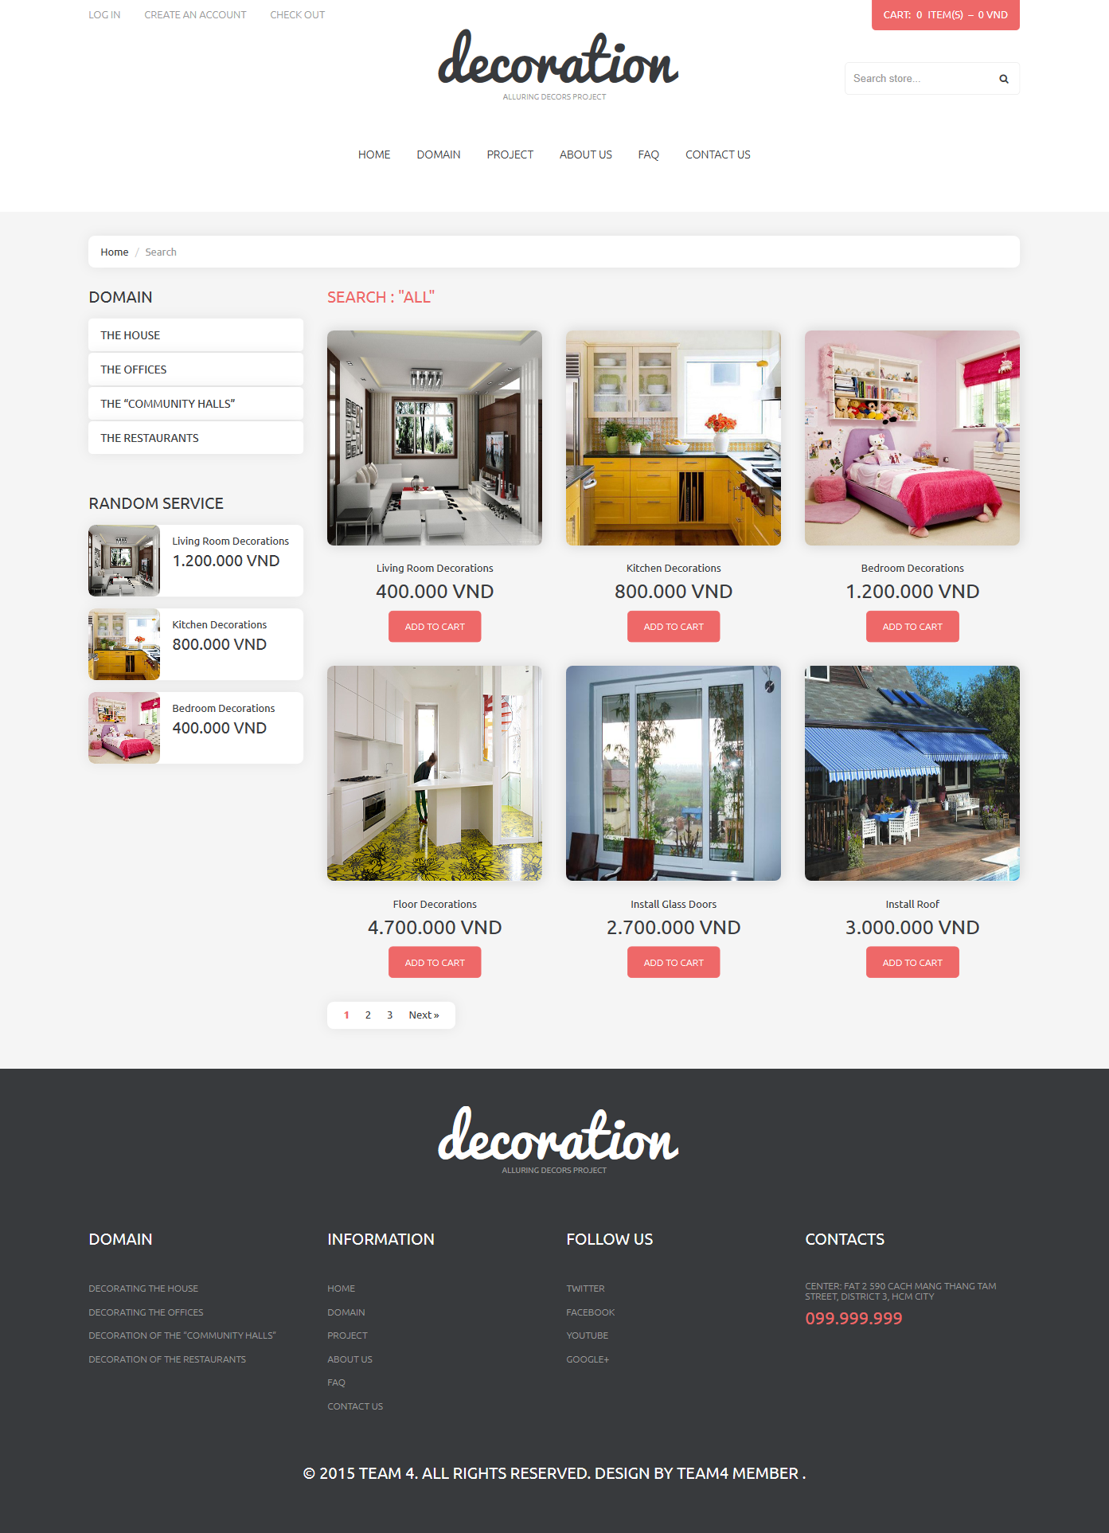

|  |  |  |  |  |  |  |
| --- | --- | --- | --- | --- | --- | --- |
| **No.** | **Name** | **Type** | **Validation** | **Event** | **Description** | **Status** |
| 1 | lbDomain | Link |  | Click | Go to domain page |  |
| 2 | gridService | List |  |  | List service belong to the domain |  |
| 3 | lbPaging | Paging |  | Click | Next and prev page |  |
| 4 | Home | Link |  | Click | Back to home |  |

* + 1. Profile Page

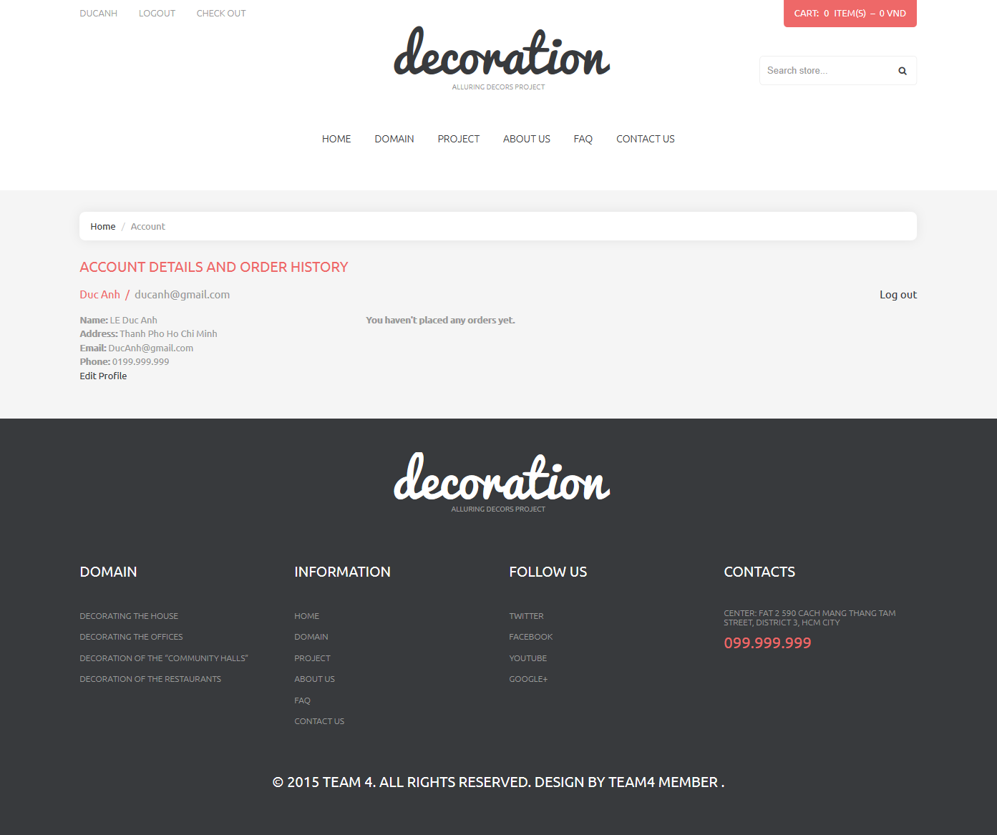

|  |  |  |  |  |  |  |
| --- | --- | --- | --- | --- | --- | --- |
| **No.** | **Name** | **Type** | **Validation** | **Event** | **Description** | **Status** |
| 1 | lbUsername | Label |  |  | Username |  |
| 2 | lbAddress | Label |  |  | Password |  |
| 3 | lbEmail | Label |  |  | Login to admin |  |
| 4 | lbPhone | Label |  |  | Remember login |  |
| 5 | lbEdit | Link |  | Click | Redirect to edit profile page |  |
| 6 | lnkLogout | Link |  | Click | Logout and redirect to Homepage |  |

* + 1. Edit Profile

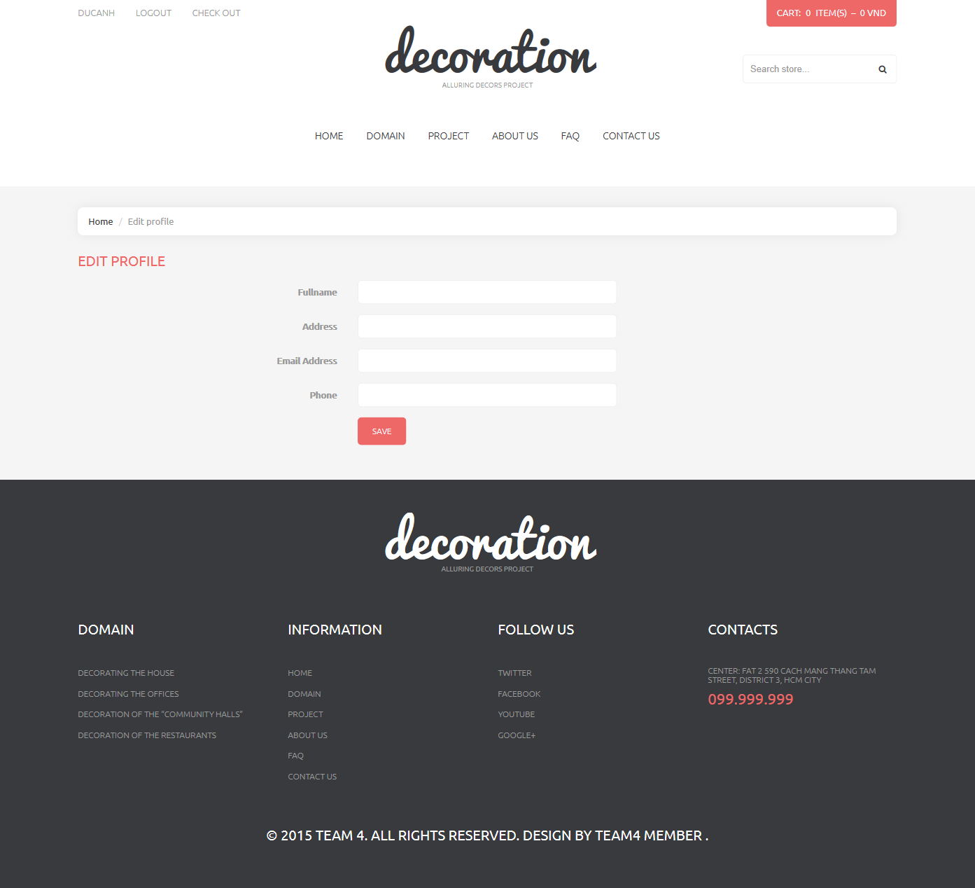

|  |  |  |  |  |  |  |
| --- | --- | --- | --- | --- | --- | --- |
| **No.** | **Name** | **Type** | **Validation** | **Event** | **Description** | **Status** |
| 1 | txtName | Text field |  |  | Fullname |  |
| 2 | txtAddress | Text field |  |  | Address |  |
| 3 | txtMail | Text field |  |  | Mail |  |
| 4 | txtPhone | Text field |  |  | Phone |  |
| 5 | btnSave | Button |  | Click | Click to save the detail to database |  |

* + 1. Change password

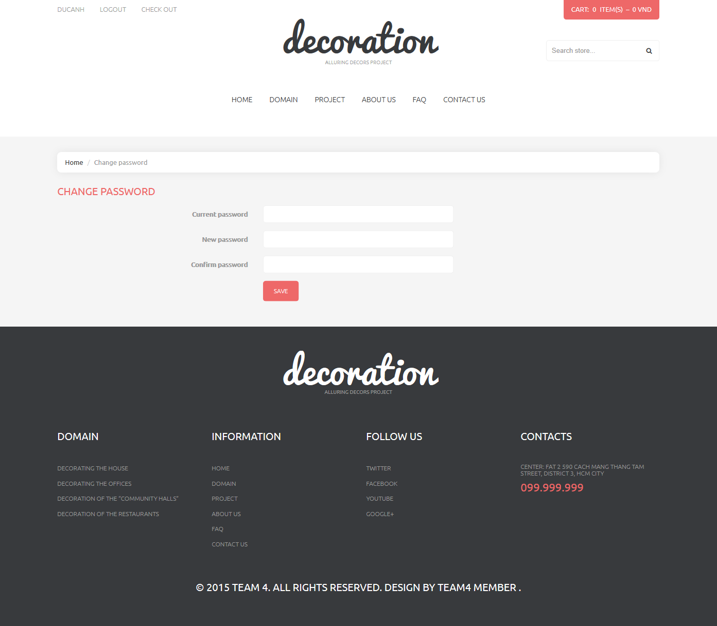

|  |  |  |  |  |  |  |
| --- | --- | --- | --- | --- | --- | --- |
| **No.** | **Name** | **Type** | **Validation** | **Event** | **Description** | **Status** |
| 1 | txtCurrentPass | Text field | Not Null |  | Current password |  |
| 2 | txtNewPass | Text field | Not Null |  | New password |  |
| 3 | txtConfirmPass | Text field | Not Null |  | Confirm password |  |
| 4 | btnSave | Button |  | Click | Click to change password |  |

* + 1. Cart Page

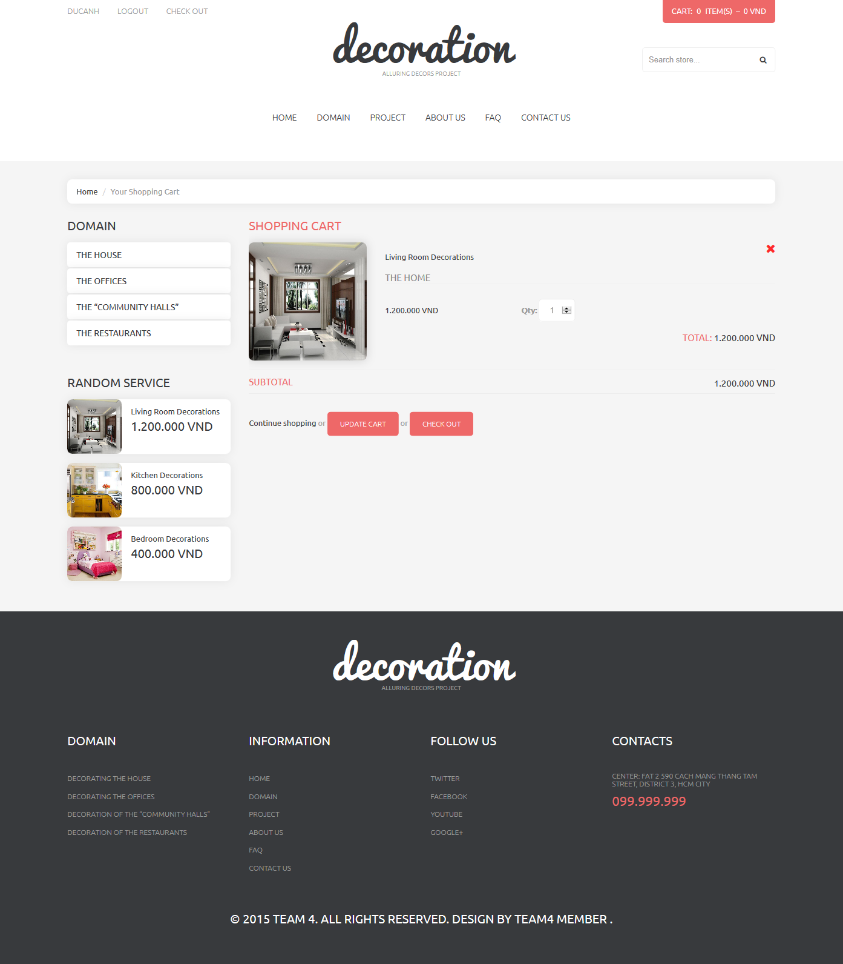

|  |  |  |  |  |  |  |
| --- | --- | --- | --- | --- | --- | --- |
| **No.** | **Name** | **Type** | **Validation** | **Event** | **Description** | **Status** |
| 1 | lbImage | Label |  |  | Service Image |  |
| 2 | lbName | Label |  |  | Service name |  |
| 3 | lbPrice | Label |  |  | Service price |  |
| 4 | txtQuantity | Text field | >0 |  | Quantity |  |
| 5 | lbTotal | Label |  |  | Total |  |
| 6 | lbSubtotal | Label |  |  | Price sub total |  |
| 7 | btnUpdate | Button |  | Click | Click to update price |  |
| 8 | btnCheckout | Button |  | Click | Click to checkout |  |

* + 1. Checkout Page

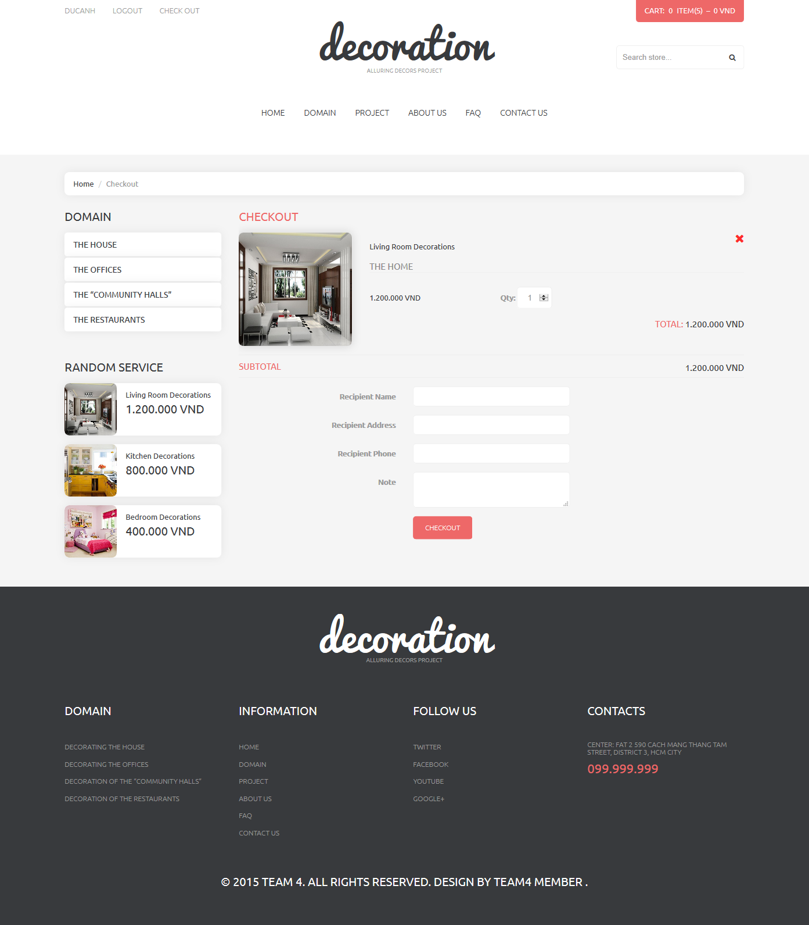

|  |  |  |  |  |  |  |
| --- | --- | --- | --- | --- | --- | --- |
| **No.** | **Name** | **Type** | **Validation** | **Event** | **Description** | **Status** |
| 1 | lbImage | Label |  |  | Service Image |  |
| 2 | lbName | Label |  |  | Service name |  |
| 3 | lbPrice | Label |  |  | Service price |  |
| 4 | txtQuantity | Text field | >0 |  | Quantity |  |
| 5 | lbTotal | Label |  |  | Total |  |
| 6 | lbSubtotal | Label |  |  | Price sub total |  |
| 7 | txtName | Text field | Not null |  | Recipient Name |  |
| 8 | txtAddress | Text field | Not null |  | Recipient Address |  |
| 9 | txtPhone | Text field | Not null |  | Recipient Phone |  |
| 10 | txtNote | Text field |  |  | Bill Note |  |
| 8 | btnCheckout | Button |  | Click | Click to checkout |  |

* + 1. FAQ Question

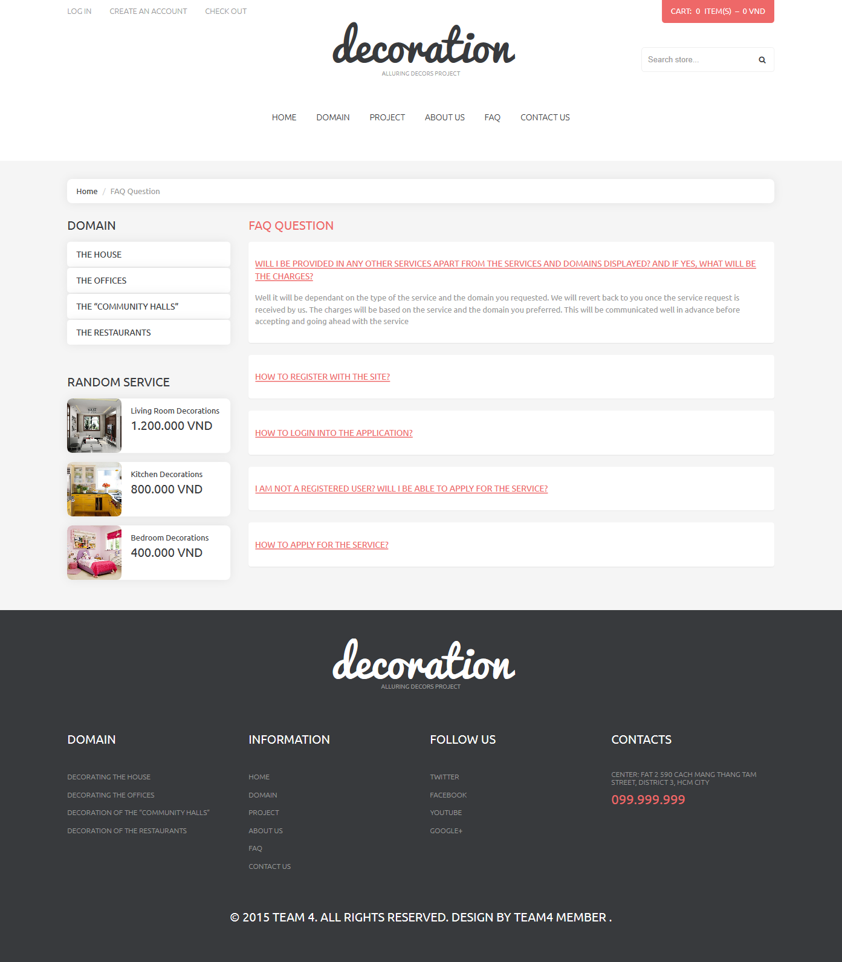

## Admin Site

* + 1. Login page

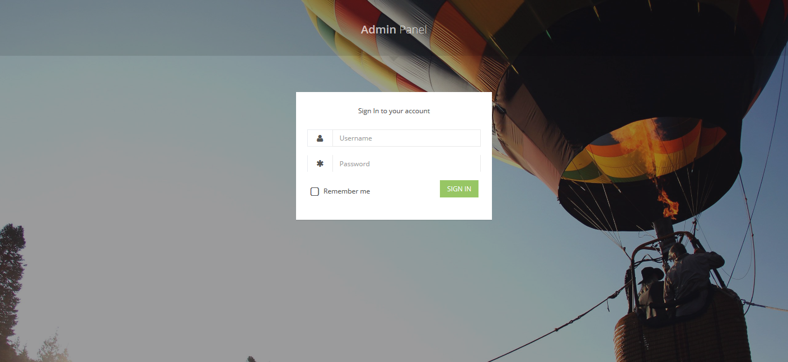

|  |  |  |  |  |  |  |
| --- | --- | --- | --- | --- | --- | --- |
| **No.** | **Name** | **Type** | **Validation** | **Event** | **Description** | **Status** |
| 1 | txtUsername | Text field | Required |  | Username |  |
| 2 | txtPassword | Text field | Required |  | Password |  |
| 3 | btnSignin | Button |  | Click | Login to admin |  |
| 4 | cboRemember | Checkbox |  |  | Remember login |  |

* + 1. Customer Manager

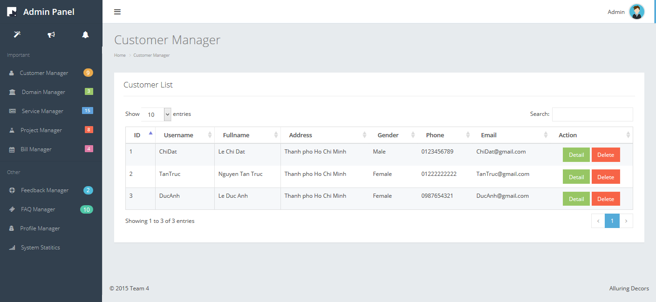

|  |  |  |  |  |  |  |
| --- | --- | --- | --- | --- | --- | --- |
| **No.** | **Name** | **Type** | **Validation** | **Event** | **Description** | **Status** |
| 1 | txtSearch | Text field |  |  | Search |  |
| 2 | btnDetail | Button |  | Click | Show detail |  |
| 3 | btnDelete | Button |  | Click | Delete |  |
| 4 | dllShowEntries | DropdownList |  | Click | Choose record number per page |  |
| 5 | lbID | Label |  |  | Customer ID |  |
| 6 | lbUsername | Label |  |  | Customer Username |  |
| 7 | lbFullname | Label |  |  | Customer Name |  |
| 8 | lbAddress | Label |  |  | Customer Address |  |
| 9 | lbGender | Label |  |  | Customer Gender |  |
| 10 | lbPhone | Label |  |  | Customer Phone |  |
| 11 | lbEmail | Label |  |  | Customer Email |  |
| 12 | btnDelete | Button |  | Click | Click to delete Customer |  |
| 13 | btnDetail | Button |  | Click | Click to show detail of Customer |  |

* + 1. Customer Detail

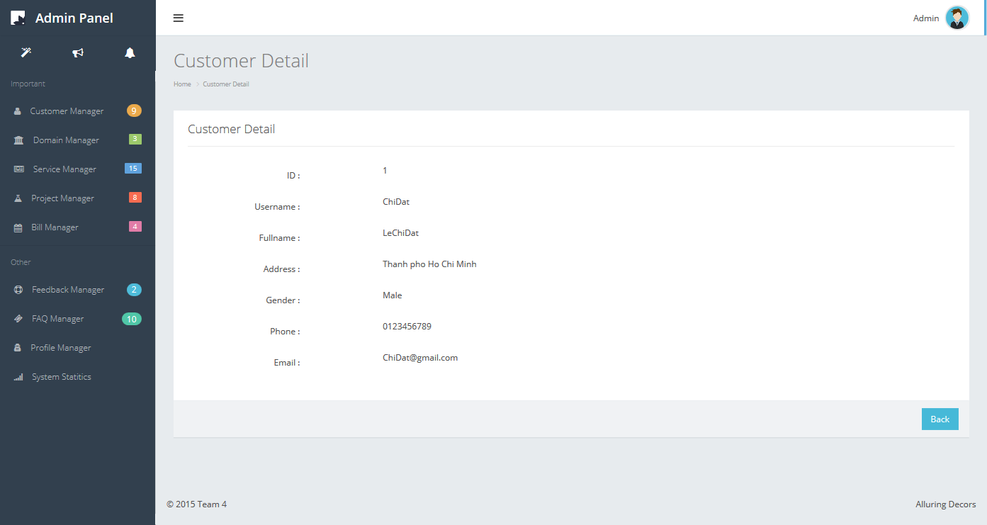

|  |  |  |  |  |  |  |
| --- | --- | --- | --- | --- | --- | --- |
| **No.** | **Name** | **Type** | **Validation** | **Event** | **Description** | **Status** |
| 1 | btnBack | Button |  | Click | Back To Customer Manager |  |
| 2 | lbID | Label |  |  | Customer ID |  |
| 3 | lbUsername | Label |  |  | Customer Username |  |
| 4 | lbFullname | Label |  |  | Customer Name |  |
| 5 | lbAddress | Label |  |  | Customer Address |  |
| 6 | lbGender | Label |  |  | Customer Gender |  |
| 7 | lbPhone | Label |  |  | Customer Phone |  |
| 8 | lbEmail | Label |  |  | Customer Email |  |

* + 1. Domain Manager

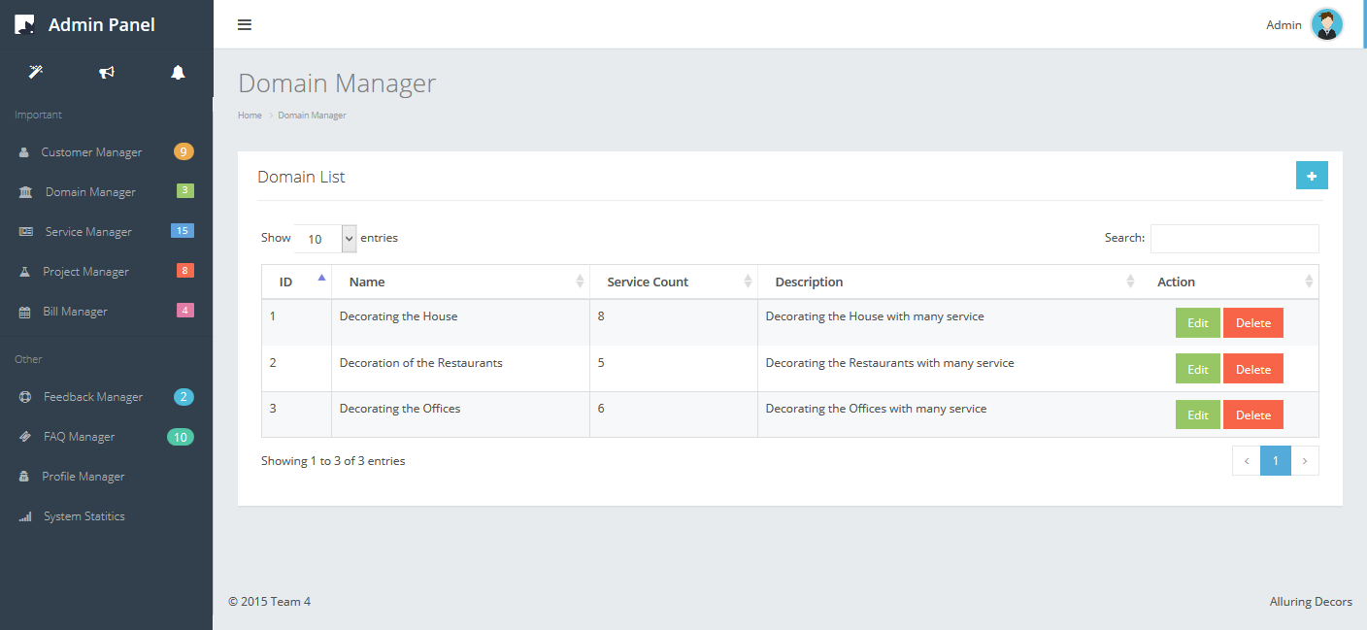

|  |  |  |  |  |  |  |
| --- | --- | --- | --- | --- | --- | --- |
| **No.** | **Name** | **Type** | **Validation** | **Event** | **Description** | **Status** |
| 1 | txtSearch | Text field |  |  | Search |  |
| 2 | btnEdit | Button |  | Click | Edit |  |
| 3 | btnDelete | Button |  | Click | Delete |  |
| 4 | btnAdd | Button |  | Click | Add new Domain |  |
| 5 | dllShowEntries | Button |  | Click | Choose record number per page |  |
| 6 | lbID | Label |  |  | Domain ID |  |
| 7 | lbName | Label |  |  | Domain Name |  |
| 8 | lbServiceCount | Label |  |  | Service Count |  |
| 9 | lbDescription | Label |  |  | Domain Description |  |
| 10 | btnEdit | Button |  | Click | Click to edit domain |  |
| 11 | btnDelete | Button |  | Click | Click to delete domain |  |

* + 1. Add Domain

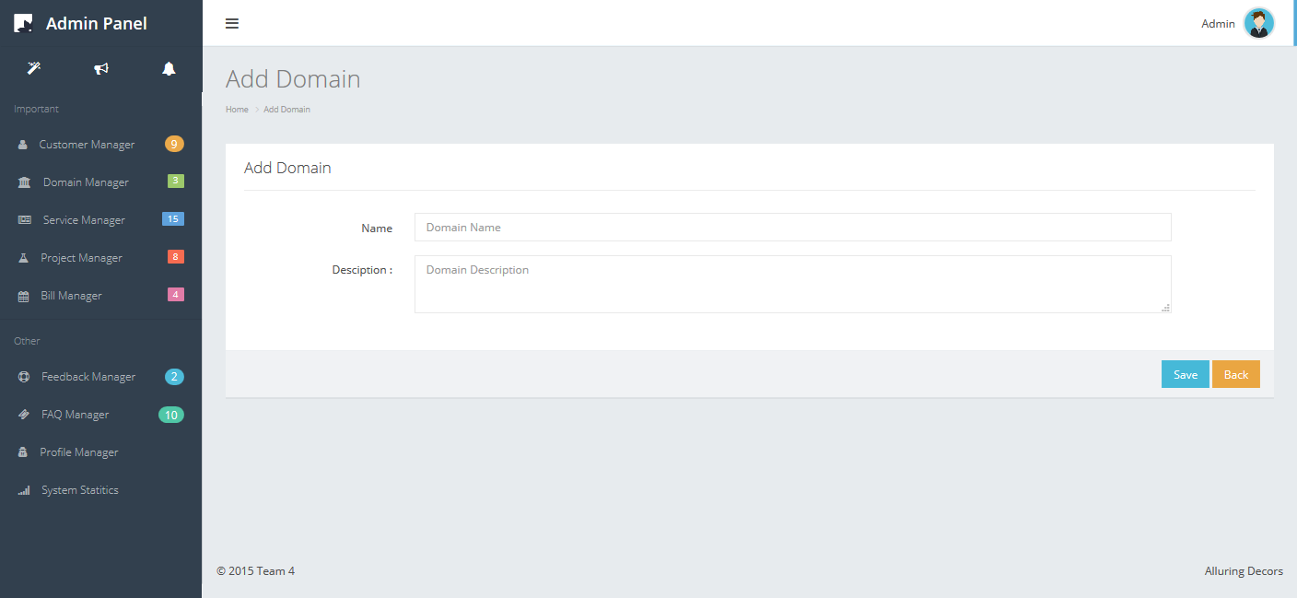

|  |  |  |  |  |  |  |
| --- | --- | --- | --- | --- | --- | --- |
| No. | Name | Type | Validation | Event | Description | Status |
| 1 | txtName | Text field | Not Null |  | Domain name |  |
| 2 | txtDescription | Text field | Not Null |  | Domain description |  |
| 3 | btnSave | Button |  | Click | Save |  |
| 4 | btnBack | Button |  | Click | Back to Domain Manager |  |

* + 1. Edit Domain

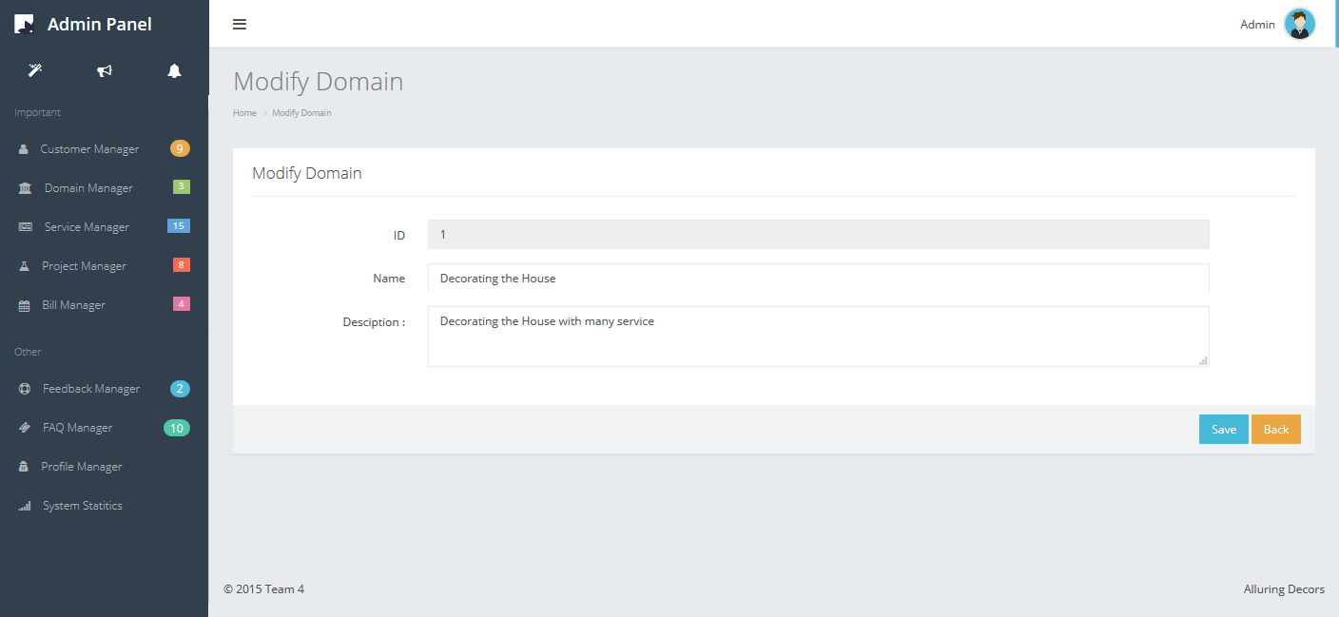

|  |  |  |  |  |  |  |
| --- | --- | --- | --- | --- | --- | --- |
| No. | Name | Type | Validation | Event | Description | Status |
| 1 | txtName | Text field | Not Null |  | Domain name |  |
| 2 | txtDescription | Text field | Not Null |  | Domain description |  |
| 3 | btnSave | Button |  | Click | Save |  |
| 4 | btnBack | Button |  | Click | Back to Domain Manager |  |

* + 1. Service Manager

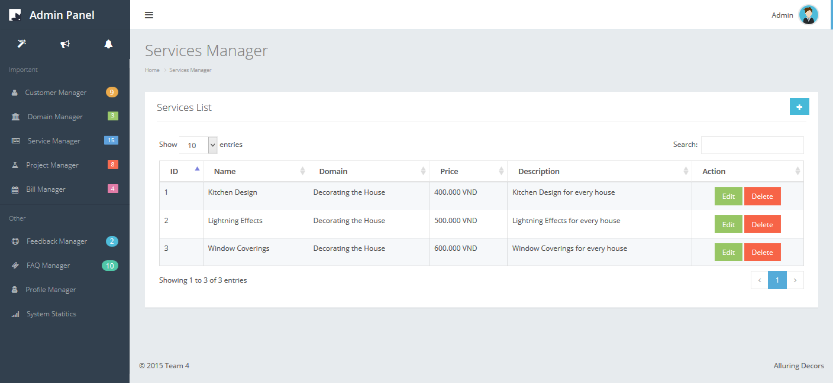

|  |  |  |  |  |  |  |
| --- | --- | --- | --- | --- | --- | --- |
| **No.** | **Name** | **Type** | **Validation** | **Event** | **Description** | **Status** |
| 1 | txtSearch | Text field |  |  | Search |  |
| 2 | btnEdit | Button |  | Click | Edit |  |
| 3 | btnDelete | Button |  | Click | Delete |  |
| 4 | btnAdd | Button |  | Click | Add new Service |  |
| 5 | dllShowEntries | DropdownList |  | Click | Choose record number per page |  |
| 6 | lbID | Label |  |  | Service ID |  |
| 7 | lbName | Label |  |  | Service Name |  |
| 8 | lbDomain | Label |  |  | Service Domain |  |
| 9 | lbPrice | Label |  |  | Service Price |  |
| 10 | lbDescription | Label |  |  | Service description |  |

* + 1. Add Service

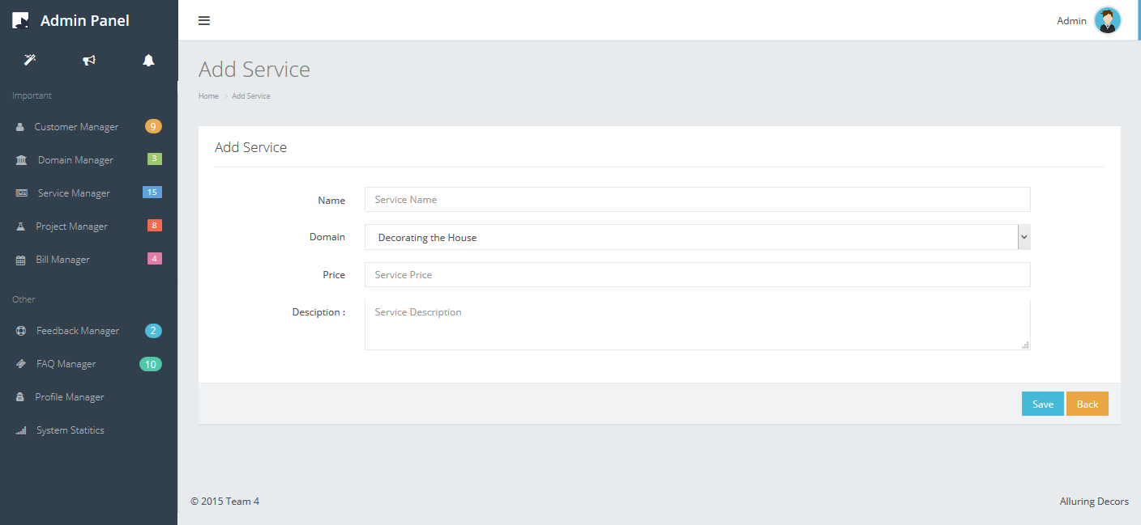

|  |  |  |  |  |  |  |
| --- | --- | --- | --- | --- | --- | --- |
| **No.** | **Name** | **Type** | **Validation** | **Event** | **Description** | **Status** |
| 1 | txtName | Text field | Not null |  | Service name |  |
| 2 | dllDomain | Dropdownlist |  |  | Choose domain |  |
| 3 | txtPrice | Text field | Not null |  | Service Price |  |
| 4 | txtDescription | Text field | Not null |  | Service description |  |
| 5 | btnSave | Button |  | Click | Save |  |
| 6 | btnBack | Button |  | Click | Back to Service Manager |  |

* + 1. Edit Service

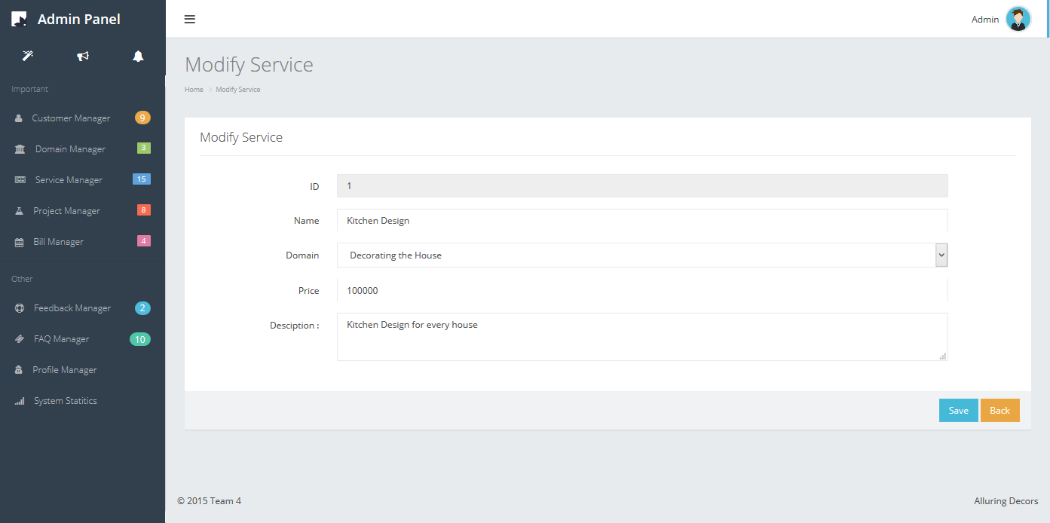

|  |  |  |  |  |  |  |
| --- | --- | --- | --- | --- | --- | --- |
| **No.** | **Name** | **Type** | **Validation** | **Event** | **Description** | **Status** |
| 1 | txtName | Text field | Not null |  | Service name |  |
| 2 | dllDomain | Dropdownlist |  |  | Choose domain |  |
| 3 | txtPrice | Text field | Not null |  | Service Price |  |
| 4 | txtDescription | Text field | Not null |  | Service description |  |
| 5 | btnSave | Button |  | Click | Save |  |
| 6 | btnBack | Button |  | Click | Back to Service Manager |  |

* + 1. Project Manager

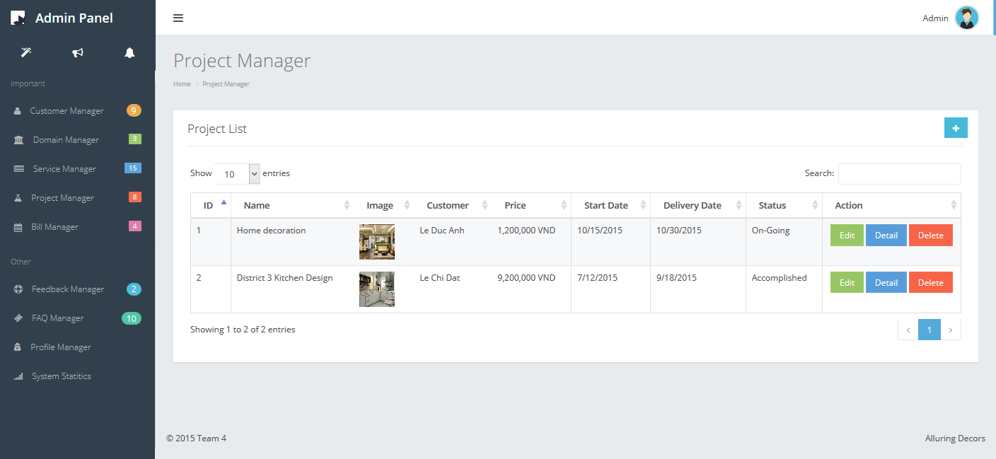

|  |  |  |  |  |  |  |
| --- | --- | --- | --- | --- | --- | --- |
| **No.** | **Name** | **Type** | **Validation** | **Event** | **Description** | **Status** |
| 1 | txtSearch | Text field |  |  | Search |  |
| 2 | btnEdit | Button |  | Click | Edit |  |
| 3 | btnDetail | Button |  | Click | Detail |  |
| 3 | btnDelete | Button |  | Click | Delete |  |
| 4 | btnAdd | Button |  | Click | Add new Project |  |
| 5 | dllShowEntries | DropdownList |  | Click | Choose record number per page |  |
| 6 | lbID | Label |  |  | Project ID |  |
| 7 | lbName | Label |  |  | Project Name |  |
| 8 | lbImage | Label |  |  | Project Image |  |
| 9 | lbCustomer | Label |  |  | Customer |  |
| 10 | lbPrice | Label |  |  | Project Price |  |
| 11 | lbStartdate | Label |  |  | Start Date |  |
| 12 | lbDeliveryDate | Label |  |  | Delivery Date |  |
| 13 | lbStatus | Label |  |  | Status |  |

* + 1. Add Project

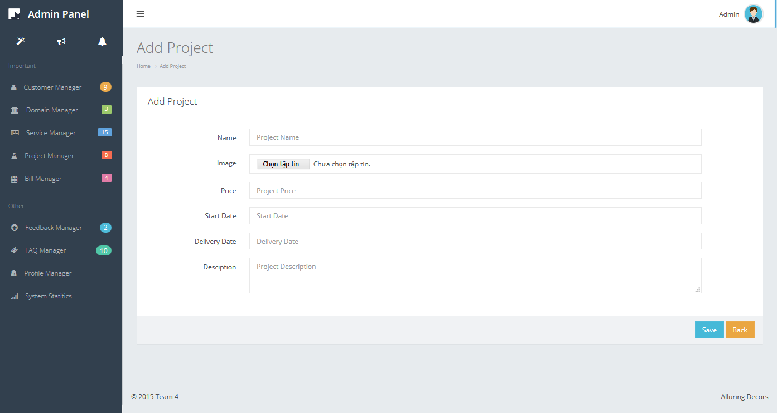

|  |  |  |  |  |  |  |
| --- | --- | --- | --- | --- | --- | --- |
| **No.** | **Name** | **Type** | **Validation** | **Event** | **Description** | **Status** |
| 1 | txtName | Text field | Not Null |  | Project name |  |
| 2 | btnImage | Button |  | Click | Choose Image |  |
| 3 | txtPrice | Text field | Not Null |  |  |  |
| 4 | txtStartDate | Text field | Not Null |  |  |  |
| 5 | txtDeliveryDate | Text field | Not Null |  |  |  |
| 6 | txtDescription | Text field | Not Null |  |  |  |
| 7 | btnSave | Button |  | Click | Save |  |
| 8 | btnBack | Button |  | Click | Back to Project Manager |  |

* + 1. Edit Project

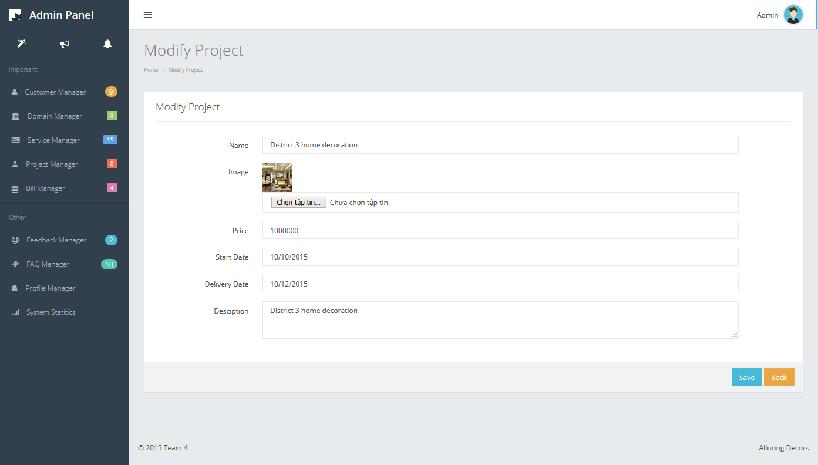

|  |  |  |  |  |  |  |
| --- | --- | --- | --- | --- | --- | --- |
| **No.** | **Name** | **Type** | **Validation** | **Event** | **Description** | **Status** |
| 1 | txtName | Text field | Not Null |  | Project name |  |
| 2 | btnImage | Button |  | Click | Choose Image |  |
| 3 | txtPrice | Text field | Not Null |  |  |  |
| 4 | txtStartDate | Text field | Not Null |  |  |  |
| 5 | txtDeliveryDate | Text field | Not Null |  |  |  |
| 6 | txtDescription | Text field | Not Null |  |  |  |
| 7 | btnSave | Button |  | Click | Save |  |
| 8 | btnBack | Button |  | Click | Back to Project Manager |  |

* + 1. Project Detail

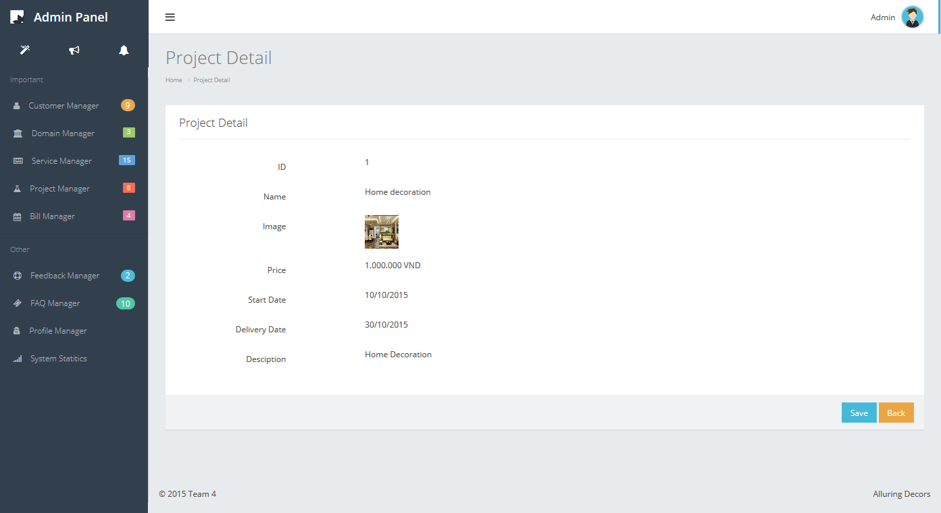

|  |  |  |  |  |  |  |
| --- | --- | --- | --- | --- | --- | --- |
| **No.** | **Name** | **Type** | **Validation** | **Event** | **Description** | **Status** |
| 7 | btnSave | Button |  | Click | Save |  |
| 8 | btnBack | Button |  | Click | Back to Project Manager |  |

* + 1. Bill Manager

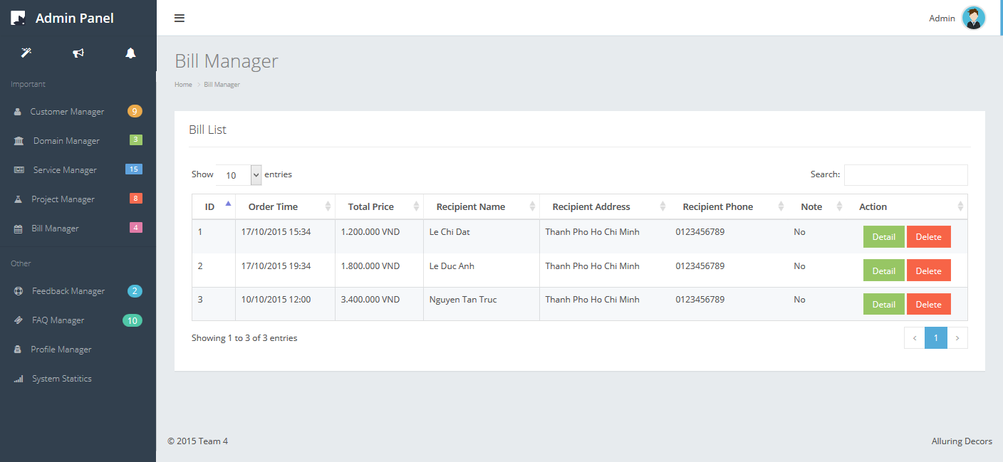

|  |  |  |  |  |  |  |
| --- | --- | --- | --- | --- | --- | --- |
| **No.** | **Name** | **Type** | **Validation** | **Event** | **Description** | **Status** |
| 1 | lbID | Label |  |  | Bill ID |  |
| 2 | lbOrderTime | Label |  |  | Order time |  |
| 3 | lbPrice | Label |  |  | Total Price |  |
| 4 | lbName | Label |  |  | Recipient Name |  |
| 5 | lbAddress | Label |  |  | Recipient address |  |
| 6 | lbPhone | Label |  |  | Recipient phone |  |
| 7 | lbNote | Label |  |  | Bill note |  |
| 8 | btnDetail | Button |  | Click | Click to view bill detail |  |
| 9 | btnDelete | Button |  | Click | Click to delete the bill |  |

* + 1. Feedback Manager

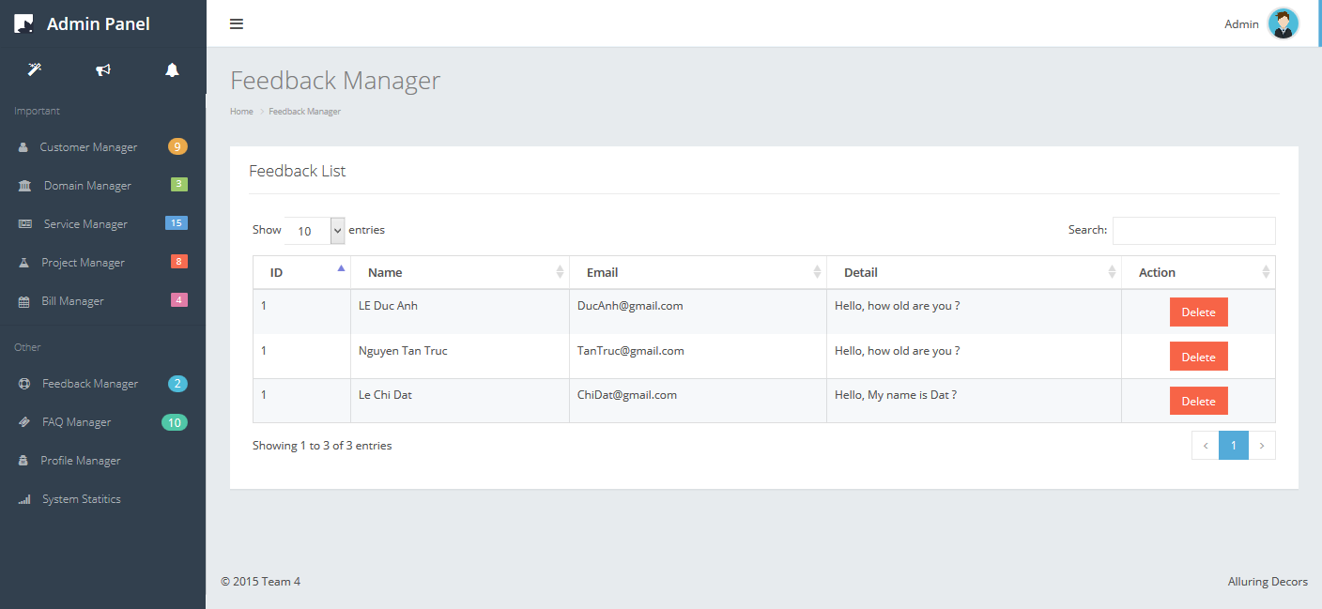

|  |  |  |  |  |  |  |
| --- | --- | --- | --- | --- | --- | --- |
| **No.** | **Name** | **Type** | **Validation** | **Event** | **Description** | **Status** |
| 1 | lbID | Label |  |  | Feedback ID |  |
| 2 | lbName | Label |  |  | Feedback name |  |
| 3 | lbEmail | Label |  |  | Email |  |
| 4 | lbDetail | Label |  |  | Feedback detail |  |
| 5 | btnDelete | Button |  | Click | Click to delete feedback |  |

* + 1. FAQ Manager

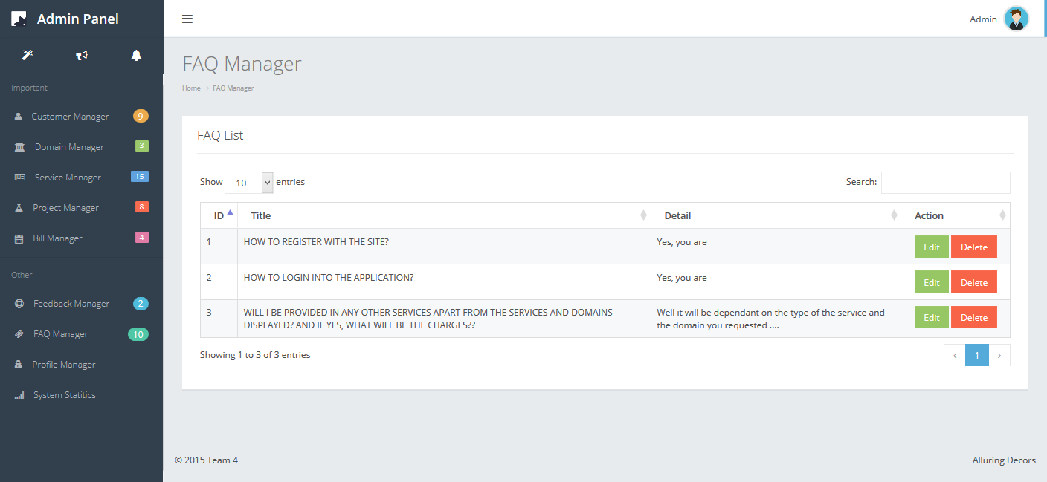

|  |  |  |  |  |  |  |
| --- | --- | --- | --- | --- | --- | --- |
| **No.** | **Name** | **Type** | **Validation** | **Event** | **Description** | **Status** |
| 1 | lbID | Label |  |  | FAQ ID |  |
| 2 | lbTitle | Label |  |  | FAQ Title |  |
| 3 | lbDetal | Label |  |  | FAQ Detail |  |
| 4 | btnEdit | Button |  | Click | Click to modify FAQ |  |
| 5 | btnAdd | Button |  | Click | Click to add FAQ |  |
| 6 | btnDelete | Button |  | Click | Click to delete FAQ |  |

* + 1. Add new FAQ

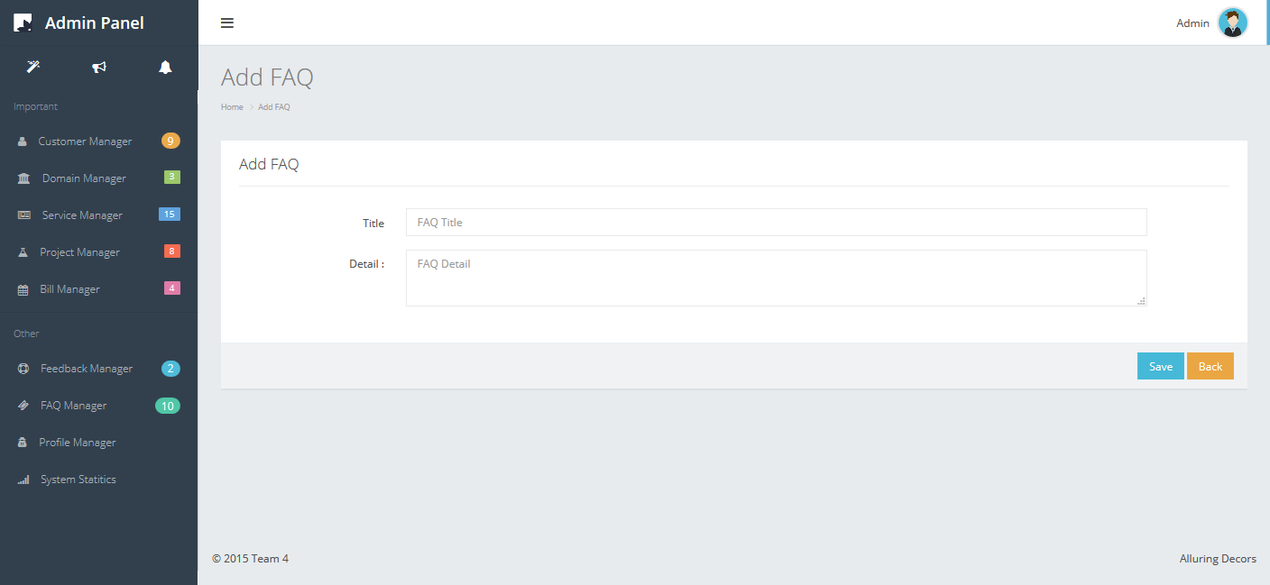

|  |  |  |  |  |  |  |
| --- | --- | --- | --- | --- | --- | --- |
| **No.** | **Name** | **Type** | **Validation** | **Event** | **Description** | **Status** |
| 1 | txtTitle | Text field |  |  | FAQ Title |  |
| 2 | txtDetail | Text field |  |  | FAQ Detail |  |
| 3 | btnSave | Button |  | Click | Click to save FAQ to database |  |
| 4 | btnBack | Button |  | Click | Click to back to faq manager |  |

* + 1. Edit FAQ

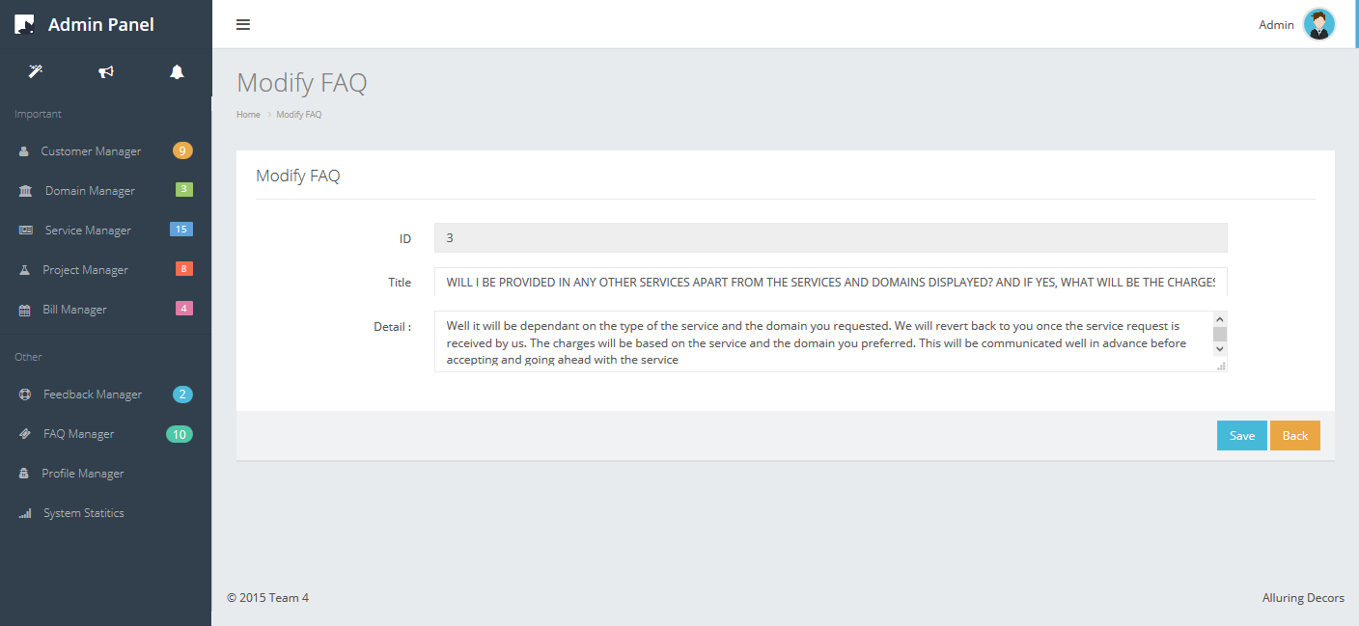

|  |  |  |  |  |  |  |
| --- | --- | --- | --- | --- | --- | --- |
| **No.** | **Name** | **Type** | **Validation** | **Event** | **Description** | **Status** |
| 1 | txtTitle | Text field |  |  | FAQ Title |  |
| 2 | txtDetail | Text field |  |  | FAQ Detail |  |
| 3 | btnSave | Button |  | Click | Click to save FAQ to database |  |
| 4 | btnBack | Button |  | Click | Click to back to faq manager |  |

* + 1. System statitics

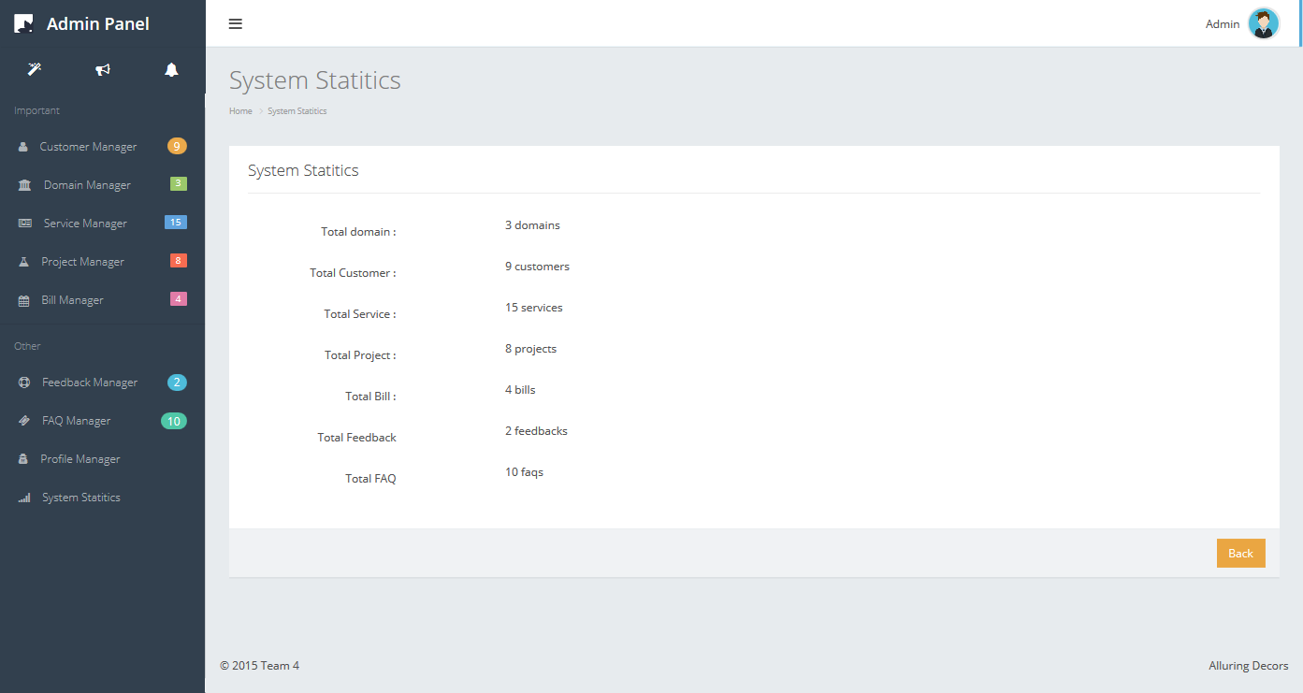

|  |  |  |  |  |  |  |
| --- | --- | --- | --- | --- | --- | --- |
| **No.** | **Name** | **Type** | **Validation** | **Event** | **Description** | **Status** |
| 1 | lbDomain | Label |  |  | Total domain |  |
| 2 | lbCustomer | Label |  |  | Total customer |  |
| 3 | lbService | Label |  |  | Total service |  |
| 4 | lbProject | Label |  |  | Total project |  |
| 5 | lbBill | Label |  |  | Total bill |  |
| 6 | lbFeedback | Label |  |  | Total feedback |  |
| 7 | lbFAQ | Label |  |  | Total faq |  |

# Task sheet

|  |  |  |  |  |  |
| --- | --- | --- | --- | --- | --- |
| Members | | Task | Date | | Status |
| No | Full Name |  | Start Date | Date Finish |  |
| 1. |  | Joint working | 3/8/2015 | 6/8/2015 | Completed |
| 2. |  | Joint working | Completed |
| 3. |  | Joint working | Completed |
| Leader | | | Faculty | | |
|  | | |  | | |
|  | | |  | | |